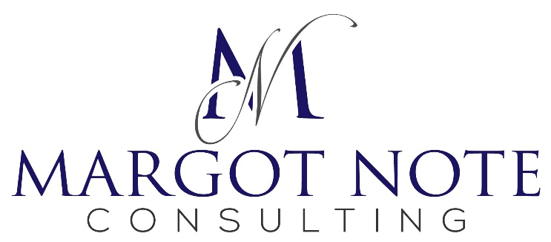

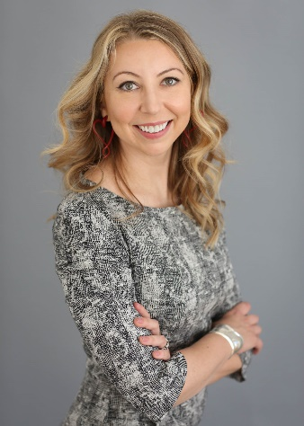 | As a lifelong lover of history, I’m passionate about preserving the past. I provide a wide range of services to help you organize your information. I rely on practical solutions and operate within your budget and at the pace you suggest.  I’ve worked with Artstor, Google, National Historical Publications and Records Commission, Rizzoli, Sarah Lawrence College, Scala, Smarthistory, and UNESCO, among others.  A client stated, “Margot’s most striking qualities are energy, creative intelligence, and versatility. She’s an astute reader, an indefatigable researcher, and a fluent writer who’s as articulate in person as she is on paper.”

Advisor
I work with clients to recommend solutions for the management and preservation of their data. My services include:
- Implementing or evaluating archives and records management programs
- Executing strategic planning and needs assessments
- Surveying, arranging, and describing text and visual collections
- Managing digitization and collaborative projects

Writer and Researcher
As an author of two books, as well as chapters, essays, and reviews, I offer the following services:
- Acting as a peer-reviewer for grant applications and journal submissions
- Creating genealogical or institutional histories
- Providing reference and research services
- Writing proposals and reports

Instructor
I lecture on information management topics throughout the United States and Europe. My services include:
- Teaching university-level research methods and primary source literacy classes
- Conducting courses on image collection management and digitization projects
- Facilitating workshops on project management for information professionals
- Developing courses and creating training materials

Photo Editor
I’m an image researcher for exhibitions, publications, videos, and online collaborations. My services include:
- Serving as a project manager for visual-based projects
- Performing image and copyright research
- Developing exhibitions and publications
- Negotiating image rights and licensing

Certified Archivist • Certified Records Manager • New York, NY
347-453-5916 • margotnote@gmail.com • margotnote.com • linkedin.com/in/margotnote

