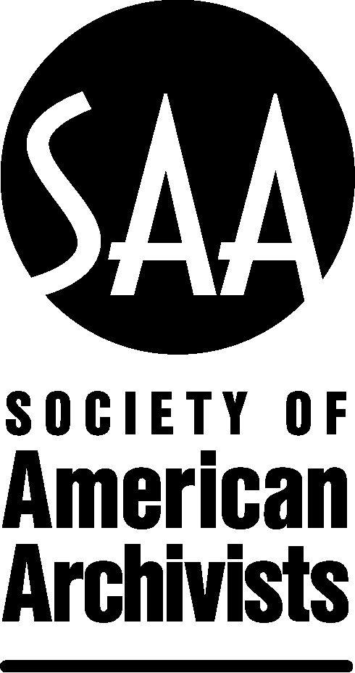

MANUSCRIPT ASSESSMENT FORM

Title of Manuscript: Making Your Tools Work for You: Building and Maintaining an Integrated Technical Ecosystem for the Archival Enterprise

Please return assessment to: Chris Prom at PublicationsEditor@archivists.org

We would appreciate receiving assessment by: August 15, 2019

Please respond to the questions listed below. Your comments should focus primarily upon concerns regarding content. However, sometimes the line between copyediting and content editing overlaps. Thus, you should call attention to sentences or paragraphs that are unclear or note whether sentence structure, terminology, or grammatical errors detract from the author’s meaning. These may be issues that a copyeditor unfamiliar with the subject matter likely will not detect.

Your comments are critical to the editorial process. Manuscript assessments typically range in length from 3–5 pages. Your comments will be compiled by the Publications Editor and forwarded to the author(s). Your identity will not be disclosed to the author(s). As a token of appreciation, upon completion of your review you will receive a complimentary copy of the book if it is published.

-----------------------------------------------------------------------------------------------------------------------------------------

- The original proposal has been provided along with the manuscript. Does the manuscript meet the criteria set forth in the Publications Board-approved proposal?

- Examine the interpretation of the author. If the book is a manual, does it reflect best practices and provide appropriate options for the varied circumstances of archivists in diverse settings? If the book is more theoretical, does it reflect debates in the profession and the literature on the topic?

- Is the book a fair and solid treatment of the subject at hand? Are there any technical inaccuracies?

- Examine the sources consulted by the author. Are there major omissions from the bibliography or citations?
- Spot check footnotes. Are there any discrepancies?

- What is the quality of the writing? How can it be enhanced?

- In my opinion, the manuscript is:
___ Accepted (no substantial revisions needed; specify minor edits)
___ Publishable with revisions (specify revisions)
___Rejected

