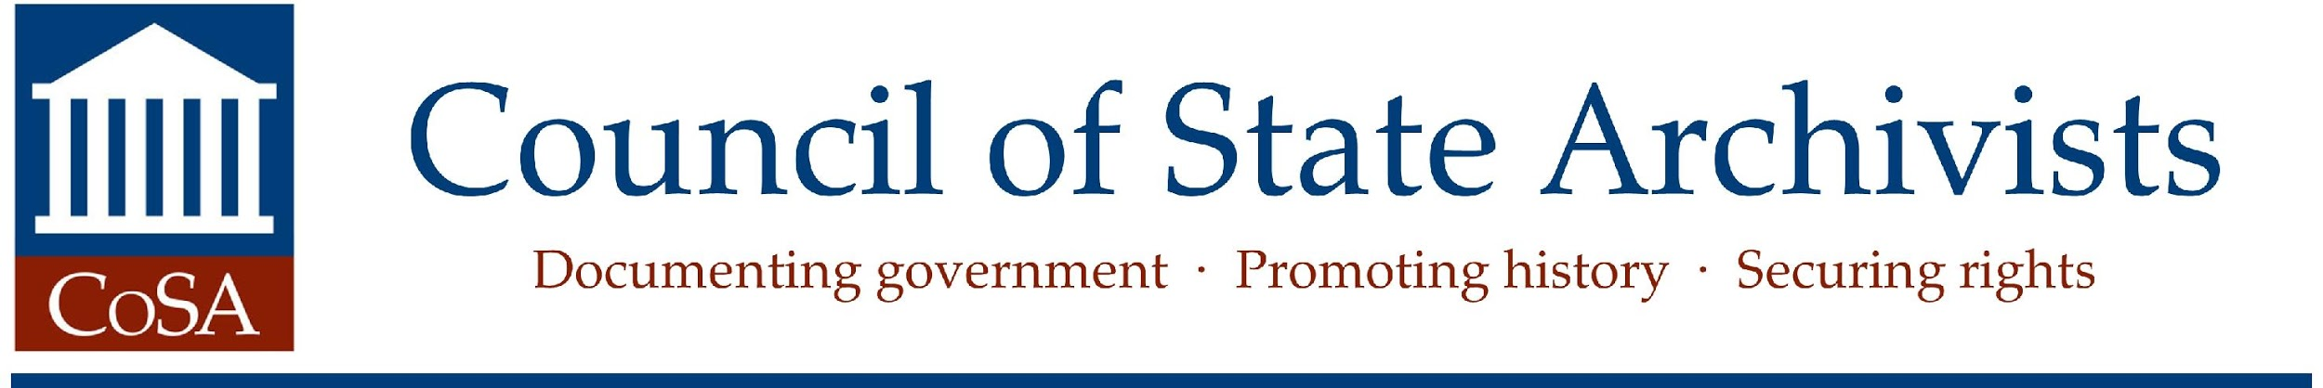

November 8, 2017

Prospectus:
State Archives Special Section for American Archivist

The Council of State Archivists proposes coordinating a special section in an upcoming 2019 issue of the Society of American Archivists’ (SAA) journal American Archivist. This special section will focus on state archives, and will be modeled on the 1997 special issue of American Archivist, Volume 60, Issue 2 (Spring 1997). The 2019 version would be a special section within the journal, rather than a full special issue devoted solely to state archives.

Special Section Contents

The section would include an introduction and three articles. The proposed articles are:

- An overview and general assessment of state archival programs, updating the 1997 article by Vicki Walch. Author: Matt Veatch
- An abridged and updated version of A National Risk. Author: Barbara Teague
- CoSA’s Research Agenda. Author: David Carmicheal and Research Task Force

Depending on the Research Task Force’s schedule of work and SAA’s production schedule, it is possible that the Research Agenda might not be complete in time for publication. If so, possible substitute articles, even or additional short articles might include: 1) an analysis of state digital archives, with several short case studies appended; 2) issues in government email; or 3) progress on CoSA’s Archives Collaborating and Cooperating with External Strategic Stakeholders (ACCESS) ACCESS Action Plan and collaborative work.

Special Section Benefits

Barbara Teague, CoSA representative, Cal Lee, incoming editor of American Archivist, and Teresa Brinati, SAA Director of Publications have discussed the special section twice via conference call and see many benefits to including a special section on state archives in the AA. First, many SAA members are not familiar with the important work and projects that state archives are undertaking and publishing about CoSA in the AA will help share information about the work of state archives to SAA members and global readers of the journal, as well. Second, CoSA’s work will be published in a refereed journal and information about CoSA and state archives will be readily accessible through the journal and its readers on JSTOR and Hathi Trust. Third, this may encourage other state archives staff to consider publishing articles, analysis, and reviews in AA, to reach a broader audience about the work of state archives.

Special Section Coordination and Schedule

Cal Lee will begin as editor of the American Archivist in January 2018, and is currently reviewing the publication schedule. In January, Cal and Teresa Brinati will work with CoSA to set schedules and coordinate the special section, and to select a guest editor for the special section.

The publication schedule currently requires a three to four-month period for the SAA Publications Board review and revision by the authors. Journal publication requires this comment period to be completed several months before the issue date. The schedule is generally as follows: for spring/summer, the content should be reviewed and revised by the previous November, and for winter, the content should be ready by May. Based on this schedule, the earliest publication date for this special section is spring/summer 2019.

I guess right now I (Barbara) am the presumed special section editor, but another volunteer would be fine with me.

