The American Archivist Reviews Section
Report to the Editorial Board
Bethany Anderson
July 8, 2017

Summary
Since becoming Reviews Editor, I have expanded the Reviews Section in a few ways, including increasing the number of reviews published in the journal; eight reviews were published in 80:1, the Spring/Summer 2017 issue, and eleven reviews were submitted for 80:2, the Fall/Winter 2017 issue. I anticipate publishing approximately ten reviews in each future issue moving forward. Additionally, I am including at least one report or other open access literature of significance to the archival profession in each issue. Lastly, I am expanding the cadre of reviewers internationally, and so far I have reviewers from Canada, the UK, and Germany.

As noted above, eight reviews were published in 80:1, eleven reviews have been submitted for 80:2, and ten reviews are currently in process for 81:1 (detailed further below). In addition, the guidelines for submitting reviews on the SAA site (which are linked on the AA site under “Submissions”) were updated on July 5, 2017: https://www2.archivists.org/american-archivist/publication-review. The updated guidelines provide prospective reviewers with additional information and guidance on writing a review, style and grammar, and the editorial and production process.

On August 7, 2016, Gloria Gonzalez became Coordinator for the Reviews Portal (RP). Initial work focused on finishing the transition of the RP from the SAA Drupal site to WordPress. The new RP officially launched on September 8, 2016: https://reviews.americanarchivist.org/. Since the new RP launched, five reviews have been published (detailed further below). Additionally, we have created a proposal to launch a podcast on the RP for interviews with authors of publications and creators of software, digital projects, etc. The proposal is provided to the Editorial Board as a separate attachment.

Reviews
Eight publication reviews were published issue 80:1, Spring/Summer 2017:
- Out of the Closet, Into the Archives: Researching Sexual Histories, reviewed by Kelly Wooten
- Track Changes: A Literary History of Word Processing, reviewed by Thomas Padilla
- Alva Ixtlilxochitl's Native Archive and the Circulation of Knowledge in Colonial Mexico, reviewed by Eric C. Stoykovich
- Personal Digital Archiving: DPC Technology Watch Report 15-01, reviewed by Erin O’Meara
- Paper Cadavers: The Archives of Dictatorship in Guatemala, reviewed by Elvia Arroyo-Ramirez
- The No-Nonsense Guide to Archives and RecordKeeping, reviewed by Kathleen D. Roe
- Description: Innovative Practices for Archives and Special Collections, reviewed by Olga Virakhovskaya
- When We Are No More: How Digital Memory is Shaping our Future, reviewed by Trevor Owens

In March 2017, eleven reviews were submitted for issue 80:2, Fall/Winter 2017:
- Latinos in Libraries, Museums, and Archives: Cultural Competence in Action! An Asset-Based Approach, reviewed by Margarita Vargas-Bentancourt
- Building Trust in Information: Perspectives on the Frontiers of Provenance, reviewed by Creighton Barrett
- Pedagogies of the Image: Photo-archives, Cultural Histories, and Postfoundational Inquiry, reviewed by Katrina Windon
- Teaching with Primary Sources, reviewed by Rachel Grove-Rohrbaugh
- Preserving Family Recipes: How to Save and Celebrate your Food Traditions, reviewed by Kira Dietz
- Digital Preservation Essentials, reviewed by Dan Noonan
- Rogue Archives: Digital Cultural Memory and Media Fandom, reviewed by Jeremy Brett
- City of Remembering: A History of Genealogy in New Orleans, reviewed by Tanya Zanish-Belcher
- Becoming a Trusted Digital Repository, reviewed by Sibyl Schaefer
- Office of the Secretary: Evaluation of Email Records Management and Cybersecurity Requirements, ESP-16-03, reviewed by David Bearman
- Privacy and the Past: Research, Law, Archives, Ethics, reviewed by Elena Danielson

Ten reviews are in process for issue 81:1, Spring/Summer 2018 (due to be submitted by August 15, 2017). Anticipated reviews for this issue include Research in the Archival Multiverse (Monash University Publishing), The Data Librarian’s Handbook (Facet), Appraisal and Acquisition Strategies (SAA), Life on Ice: A History of New Uses for Cold Blood (UChicago Press), Participatory Heritage (Facet), The Science of Managing our Digital Stuff (MIT Press), among others.

Highlights
The guidelines for submitting reviews on the SAA site (and linked on the AA site under “Submissions”) were updated on July 5, 2017: https://www2.archivists.org/american-archivist/publication-review. The updated guidelines provide additional information about style and grammar, copyright, the open access policy for reviews, the process for receiving a review copy of a publication, and an overview of the editorial and production process. The guidelines were also renamed “Publication Review Guidelines” (previously “Book Review Guidelines”) to better encompass the types of works to be reviewed (such as reports, as noted above).

As noted above, the reviews have been expanded in several ways, including by number, types of publications reviewed, and by including more international reviewers (so far from the UK, Germany, and Canada). Reviews of publications have covered the following topics, such as the history of archives; personal digital archiving; media history and theory; gender and sexuality archives; archives in public libraries; donors and archives; digital preservation; historical anthropology at the nexus of social justice and archives; recordkeeping in the UK; teaching with primary sources; evolving conceptions of “provenance”; and “fanfic” archives. Reviews represent publications from an array of publishers, including Rowman and Littlefield, SAA, Facet Publishing, ALA, and various university presses.

In conversation with Greg Hunter, Teresa Brinati, and Abigail Christina, we are currently exploring the ways in which Allen Press’ PeerTrack can be customized for the reviews editorial workflow. I anticipate that once some changes can be made and pending issues are resolved, we can hopefully start using PeerTrack for review submissions.

On September 8, 2016, the new WordPress Reviews Portal was launched: https://reviews.americanarchivist.org/. The new RP can also be accessed through the navigation bar at americanarchivist.org (and likewise, a link to AA was included in the RP navigation bar) to enhance access, ensure more cohesive branding, and raise the visibility of the RP. We were grateful for the help and good work of AA Editorial Board Intern Dana Bronson, who assessed of all the resources, software, and digital projects listed on the Ideas for Reviews page to check which links were still current or had changed.

Since the move to WordPress (which also gives us very useful analytics), the number of page views for the RP has increased, especially for 2017. In 2016, the site was viewed was viewed 1,528 times by 458 unique visitors. Thus far in 2017 (January-July), a total of 1,156 unique visitors have visited the site 2,396 times. This is an increase from 584 page views by 489 unique visitors for January-July 2015. In addition to the increased visibility through the WordPress site and linking to AA, we’ve focused efforts on publicizing new reviews through SAA’s Twitter account and In The Loop (thanks to the help of Abigail Christian).

In a separate attachment to the Editorial Board is a proposal to launch a podcast with interviews of authors of publications and creators of digital resources. The new WordPress platform has enabled us to increase engagement with readers and garner new interest from prospective reviewers. The functionality of the platform allows us to not only post reviews, but also potentially other types of content. We anticipate that the podcast would enable us to engage with the archival literature and resources in ways that complement the publication reviews in the journal and the reviews on the RP.

Reviews Portal (Gloria Gonzalez)
The Review Portal team announced the redesigned version of The American Archivist Reviews Portal on September 8, 2016. We worked with Matt Black and Abigail Christian to migrate all of the content from the previous SAA Drupal site to WordPress and customize the look and feel of the site. Our goal was to provide a platform that is uniform with The American Archivist’s online presence that gives readers the ability to easily share content via social media and view the site on tablet and mobile devices.

Since the new website launched, six reviews were posted to the Review Portal. These reviews all emphasize technology in archives, digital projects, and tools that support archives access and description. AVCC, a web-based open-source tool used to catalog and assess audiovisual collections, was reviewed. Digital collections that live on platforms of various sizes were also reviewed: The Bauhaus, the Digital Repository of Ireland, and Explore Chicago Collections. Additionally, two in-depth, practical guides were reviewed as well: The Activists’ Guide to Archiving Video, and Digitizing Orphan Works: Legal Strategies to Reduce Risks for Open Access to Copyrighted Orphan Works. All six reviews are linked below in chronological order:

- AVCC, reviewed by Allyson Smally (August 1, 2016)
- The Bauhaus, reviewed by Margot Note (February 9, 2017)
- The Activists’ Guide to Archiving Video, reviewed by Jimi Jones (May 3, 2017)
- Digital Repository of Ireland, reviewed by Johanna Russ (May 8, 2017)
- Digitizing Orphan Works: Legal Strategies to Reduce Risks for Open Access to Copyrighted Orphan Works, reviewed by Chloé Pascual (May 22, 2017)
- Explore Chicago Collections, pending review by Matthew Strandmark (~July 10, 2017)

In 2016, the site was viewed was viewed 1,528 times by 458 unique visitors. So far in 2017, a total of 1,156 unique visitors have visited the site 2,396 times. These visitors are in 69 countries. The table below breaks down visitors by the top 20 most common countries.

As of July 2017, the top five viewed reviews are The Activists' Guide to Archiving Video (388 views), Digitizing Orphan Works: Legal Strategies to Reduce Risks for Open Access to Copyrighted Orphan Works (232 views), Digital Repository of Ireland (172 views) The Bauhaus (92 views), and an Archivematica review that was originally posted on the previous website on March 2, 2015 (70 views).

Average Views Per Day by Month and Year
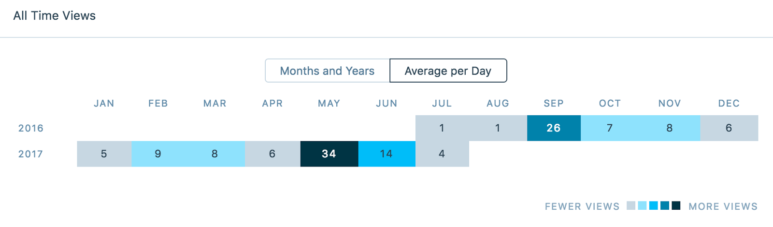
Data Captured on July 1, 2017

All Time Views by Month and Year
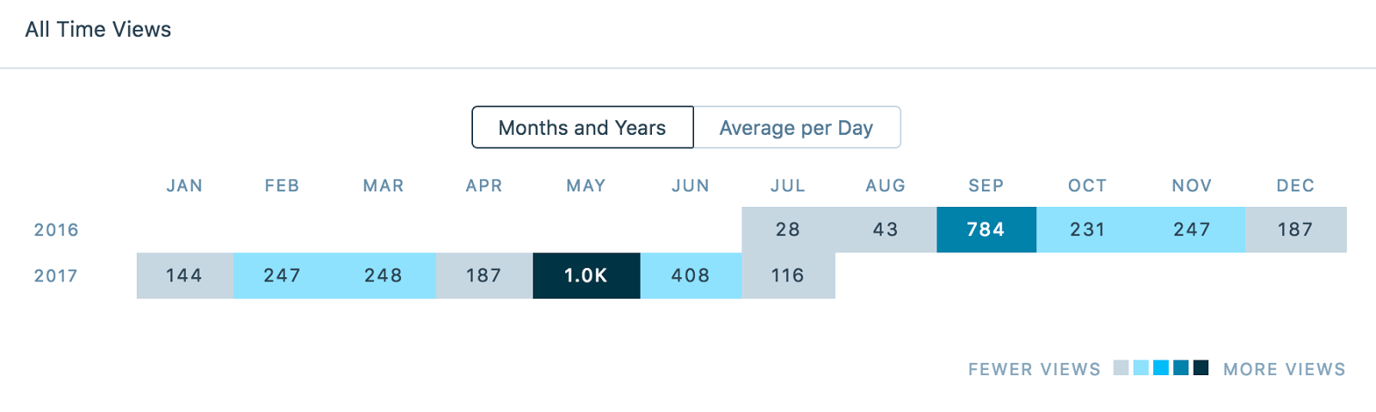
Data Captured on July 1, 2017

Visitors by Top 20 Countries
Country | Visitors
United States | 1836
Canada | 75
Australia | 54
Ireland | 39
United Kingdom | 39
Brazil | 21
Spain | 20
Germany | 19
China | 19
France | 18
India | 17
South Korea | 17
Latvia | 15
South Africa | 14
Japan | 12
Italy | 12
Taiwan | 10
Croatia | 9
Philippines | 9
Portugal | 8
Data Captured on July 1, 2017

Future Goals
Over the next year, I hope to continue expanding the diversity of reviews and reviewers in the journal. We hope we can continue to draw more visitors to the Reviews Portal and explore the possibility of implementing a podcast as well as other new types of content on the RP.

For example, see Erin O’Meara’s review of the DPC Technology Watch report Personal Digital Archiving in issue 80-1, http://americanarchivist.org/doi/pdf/10.17723/0360-9081.80.1.240.
According to previous Google Analytics data collected prior to the move to WordPress. We currently don’t have the 2016 Google Analytics data for the RP.

