Reference, Access, & Outreach Section Election: Candidate Statements

Candidates for Vice Chair/Chair Elect

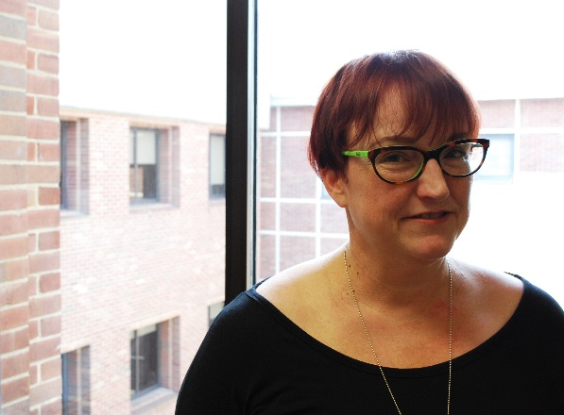
Jean Green

Job title: Head of Special Collections, Preservation and University Archives

Education: MLS, University at Albany – SUNY; MA in History, SUNY Cortland

Candidate Statement:
I am pleased and excited to be considered for the Reference, Access and Outreach leadership team. I feel that one of the most important duties that an archivist/curator/special collections professional does is to provide access to materials through providing reference, guidance and orientation to those using the collections. Outreach in all of its forms can be equally important in that it provides information about a repository’s collections and brings users in to access the collections. And, indeed, SAA states in its Core Values of Archivists that “Archivists promote and provide the widest possible accessibility of materials….” I would like to work to be sure that archives and special collections are accessible to everyone through the hard work that we all do every day.

Work Experience:

Head of Special Collections, Preservation and University Archives, Binghamton University – SUNY, Binghamton, NY, 2006-present;

Assistant Library Director/College Archivist, The College of Saint Rose, Albany, NY, 1997-2006;

Archivist, Albany Institute of History and Art, Albany, NY, 1995-1997;

Senior Curatorial Associate, Arizona Historical Foundation, Tempe, AZ, 1993-1995

Relevant Professional Service (Selected):

“Big-11” New York State Preservation Officers, 2006-present; South Central Regional Library Council Advisory Committee, 2013-present; Co-Chair, ALA/SAA/AAM Joint Committee on Libraries, Archives and Museums (CALM) (SAA Representative), appointed, 2014-2016; Mid-Atlantic Regional Archives Conference (MARAC), Finance Committee, appointed, 2014-2016; ALA/SAA/AAM Joint Committee on Libraries, Archives and Museums (CALM) (SAA Representative), appointed (two terms), 2011-2015; Chair, Local Arrangements Committee, New York Archives Conference (NYAC) 2014 meeting, Binghamton, NY; Steering Committee, Reference, Access and Outreach Section, Society of American Archivists (SAA), elected, 2012-2014

Relevant Publications & Presentations (Selected):
De Rouen, A. and Green, J. (2015) “From Brooklyn to Binghamton: The Vera Beaudin Saeedpour Kurdish Library & Museum Collection at Binghamton University,” The Reading Room: A Journal of Special Collections, Volume 1, Issue 2, 2016; Mid-Atlantic Regional Archives Conference (MARAC) Fall Meeting, “Documenting Kurds at Binghamton University,” as part of a panel entitled “From Creation to Donation: How Archivists Empower Hidden Communities,” Speaker, October 9, 2015, Roanoke, VA; Green, J. and Vega, L. (2014) “Using Pinterest as a Marketing and Alternative Online Exhibition Tool for Special Collections,” The Journal of Digital Media Management, 3 (2); Mid-Atlantic Regional Archives Conference (MARAC) Spring Meeting, “Pop Tarts: Images of Women in Popular Culture,” Session Creator, Chair, and Speaker, April 26, 2014, Rochester, NY; Film Area of the Popular Culture Association/American Culture Association National Conference, “Reform School Girls and Wasp Women: Women in B-Films,” Speaker, April 2014, Chicago, IL.; Annual Meeting of the Society of American Archivists (SAA), “From Brooklyn to Binghamton: the Saeedpour Kurdish Collection at Binghamton University,” Speaker, August 17, 2013, New Orleans, LA.

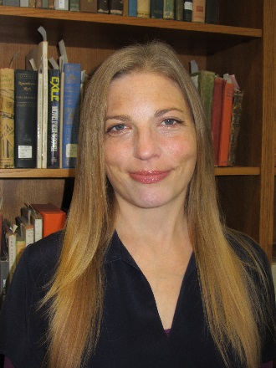
Alison Stankrauff

Job title: Archivist and Associate Librarian, Indiana University South Bend

Education: Wayne State University, Detroit, Michigan -- Masters in Library and Information Science; Archival Administration Program

Candidate Statement:
I’m Alison Stankrauff, Archivist and Associate Librarian at Indiana University South Bend. I’m adamant about the importance of the archival record that we collect, protect, make accessible. I feel deeply committed to connecting people with the archival record. I do my work with a service ethic, working with students, faculty, staff at my campus – and the public beyond. I love making history and archival collections available to people. I’ve taught classes linking primary sources with undergraduate students at my campus and have seen just how this demystifies history for them. I am active in my community, serving on the Collections Committee for the Michiana Jewish Historical Society, on the Collections Committee for the South Bend History Museum, a committee member of the city-wide South Bend Bicycle Action Taskforce. I’m also active in the Society of American Archivists, Midwest Archives Conference, Society of Indiana Archivists, and the Indiana Library Federation.

Work Experience:
- Campus Archivist and Associate Librarian, Indiana University South Bend, November 2004 to Present;
- Archival Resident, Jacob Rader Marcus Center of the American Jewish Archives, March 2003 to October 2004
- Technician, Archives of Labor and Urban Affairs, Walter P. Reuther Library, Wayne State University, April 2002 to March 2003
- Technician, Detroit News Photograph Collection, April 2002 to August 2002
- Technician, National Association of Letter Carriers Collection, August 2002 to March 2003
- Assistant Conservator, Society of Women Engineers Exhibit, May 2002 to September 2002

Relevant Professional Service (Selected):
- Society of American Archivists Reference, Access, and Outreach Section Teaching with/about Primary Sources Working Group 2014 –
- Society of American Archivists Reference, Access, and Outreach Section Nominating Committee 2014 –
- Society of American Archivists Reference, Access, and Outreach Section Steering Committee 2011 –
- Society of American Archivists Mentoring Subcommittee Co-Chair 2012 – 2014
- Society of American Archivists Mentoring Subcommittee 2011 – 2014
- Midwest Archives Conference MAC Pals Task Force 2014 –
- Indiana Library Federation Reference Division Chair, 2009 – 2010; Vice-Chair/Chair Elect for 2007-2008; Director 2008 – 2009
- Indiana University Bicentennial (University-Wide – Across 8 Campuses) – Council of University Historians: Historian of the IU South Bend Campus, 2015 –
- Indiana University Institutional Repository Planning Committee (University-Wide – Across 8 Campuses), 2008 –
- Indiana University Oral History Committee (University-Wide – Across 8 Campuses), 2008 –
- Indiana Bicentennial Committee – St. Joseph County, 2015 – 2016
- Committee Member of the South Bend 150 Anniversary Celebration, IU South Bend Committee, 2014 – 2015.
- Collections Committee Board member for the History Museum (South Bend), 2013 –
- Committee member for a community-wide effort to save the John Lewis Casaday Costume Collection, 2014 –
- Needs Assessor for the Archives of the Jewish Federation of St. Joseph Valley, 2010 –
- Bicycle Friendly Community Reviewer – South Bend, 2016
- City-Wide Bicycle Friendly Community Review Board, 2015

Relevant Publications & Presentations:
Publications

Stankrauff, Alison H.; Sommer, Tom; and Ganz, Michelle (2016) "The How and Why of Mentoring," Journal of Western Archives: Vol. 7: Iss. 1, Article 2.
Available at: http://digitalcommons.usu.edu/westernarchives/vol7/iss1/2.

Stankrauff, Alison, Catherine Page-Vanore, Katie Madonna Lee. “Partnership in the Preservation of Rustbelt Queer History.” Archive Journal 5.3 (2015): n. pag. Web. November 24, 2015. Available at: http://www.archivejournal.net/issue/5/archives-remixed/partnership-in-the-preservation-of-rustbelt-queer-history/ .
Stankrauff, Alison et al. “Which Hat Are You Wearing: ‘You Need What? When?’” (Session 208) American Archivist Online Supplement to Vol. 74 (2013): n. pag. Web.
Case Study for book published by the Society of American Archivists. “Reference”, featured in The Lone Arranger: Succeeding in a Small Repository, by Christina Zamon. Published January 2012.
Article for Society of American Archivists journal, American Archivist Electronic edition, Fall/Winter 2011 American Archivist (Vol. 74, No. 2). “Service - Balancing Working with Others and Working in a Lone Arranger Shop”.
Presentations (Selected, Recent)
Without Borders LGBTQ ALMS Conference, London June 2016: “Legacy, Trust, and Legitimacy: Challenges in Developing and Promoting LGBTQ Collections in Small Repositories” (Panelist)

College Arts Association Conference, Washington D.C., February 2016: “Partnership in Preservation of Rustbelt Queer History” (Panelist)

St. Mary’s College Panel Discussion, Notre Dame, Indiana, December 2015: Panelist in Invited Talk, “What You Can Do With a History Degree”.

Great Lakes History Conference, Grand Rapids, Michigan, October 2015: “Partnership in Preservation of Rustbelt Queer History” (Panelist)

Society of Indiana Archivists Annual Conference, Indianapolis, April 2014: Panelist in Session, “Innovative Outreach”.

Indiana University South Bend Panel Discussion, February 2014: Panelist in University Center for Excellence in Teaching (UCET) Session "Students Success Through Internships: Tips for Best Practices from Experienced Faculty and Staff Mentors".

Information Literacy Colloquium 2013, New Albany, Indiana, August 2013: Co-Presenter in Breakout Session, “Learning History by Doing History: A Sample Assignment for Incorporating Archival Research into History Coursework”.

Indiana University Librarians Day 2013, Indianapolis, June 2013: Presentation, “Learning History by Doing History: A Sample Assignment for Incorporating Archival Research into History Coursework”.

Candidates for Steering Committee

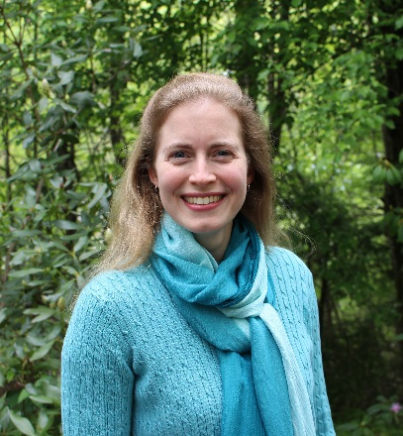
Greta Browning

Job title: Reference Archivist/Librarian and Curator of Rare Books and Manuscripts, Special Collections, Appalachian State University

Education: MLS, North Carolina Central University, 2012; MA in Public History, North Carolina State University, 1999

Candidate Statement:
I spend the majority of each working day in reference-access-outreach mode, whether corresponding with researchers, training student assistants at the reference desk, teaching instruction sessions using the collections, developing new exhibits, or hosting events related to the collections. The reality is that reference and outreach duties can pull a person in many directions on a daily basis. I look to the RAO section for inspiration and rejuvenation. The section’s activities (such as the TPS Unconference, Marketplace of Ideas, TPS bibliography work) and its members challenge me to think in new ways and revitalize me so that I return to the day-to-day refreshed. I would like to serve on the steering committee to continue the section’s energy, as well as to help shape future activities. My personal goals to find creative ways to solve practical problems and to successfully reach today’s wide range of archival users align well with RAO’s. I hope to contribute through election to the Steering Committee.

Work Experience: Reference Archivist/Librarian, 2006-present, Curator of Rare Books & Manuscripts, 2009-present, Special Collections, Appalachian State University; Processing and Oral History Archivist, Richard B. Russell Library for Political Research and Studies, University of Georgia, 2001-2006; Archivist, American Dance Festival, 1999-2001; Project Archivist, Forest History Society, 1999; Digital Projects Archivist, Special Collections and University Archives, North Carolina State University, 1999; Assistant Archivist, Missouri Historical Society, 1996-1997.

Relevant Professional Service:
Society of American Archivists: Member since 1997; RAO, Teaching with Primary Sources Working Group / Bibliography team, 2015-present / Society of North Carolina Archivists: Managing Co-Editor, Journal for the Society of North Carolina Archivists, 2007-2009; Editor, The North Carolina Archivist newsletter, 1999-2001; Chair, Local Arrangement Committee, 2008; Member-at-Large, 2007-2008; Nominating Committee, 2000 / Society of Georgia Archivists: Editor, SGA Newsletter, 2006.

Relevant Publications & Presentations:
Publications

“Tablet and Codex, Side by Side: Pairing Rare Books and E-Books in the Special Collections Classroom,” in Educational Programs: Innovative Practices for Archives and Special Collections, edited by Kate Theimer. Lanham, Maryland: Rowman & Littlefield, 2015.

“Processing Political Collections,” with Mary McKay, in American Political Archives Reader, Lanham, Maryland: Scarecrow Press, 2009.
A variety of book and website reviews for Journal for the Society of North Carolina Archivists and the North Carolina Historical Review.
Presentations
“Outreach through Collections: A Collaborative Design Project,” with Alex McAllister, March 2016, ARLIS/NA + VRA Joint Conference, Seattle, Washington
“Pairing E-Books and Rare Books to Improve Student Research,” E-Poster, Tech4Teach Fair, February 2016, Appalachian State University, Boone, North Carolina
“Combining Wargames and Archives to Teach the Historical Process,” with Judkin Browning, October 2008, Society of North Carolina Archivists Fall Meeting, Boone, North Carolina
Panelist, “It Happened in Chicago: Highlights from the 2007 SAA Annual Meeting,” October 2007, Society of North Carolina Archivists Fall Meeting, Elizabeth City, North Carolina

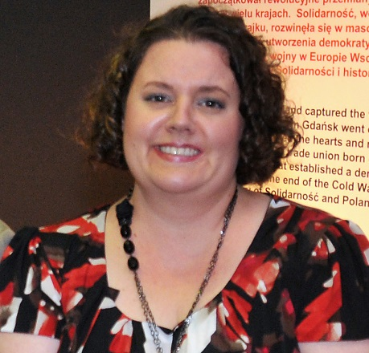
Kristen Chinery
Job title: Reference Archivist, Walter P. Reuther Library, Wayne State University

Education:
Master of Library and Information Science, Wayne State University, 2006; Master of Arts (History), Wayne State University, 2000; Archival Administration Certificate, Wayne State University, 1999.

Candidate Statement:
The work of reference, outreach, and access is at the very heart of what we do as archivists. If you strip away all other responsibilities to reach the essential element of the profession, it is service. My desire to be part of RAO’s leadership is based on my belief that we, as a profession, need to focus on the importance of service in its varied forms and how it impacts all constituents – from individual researchers to the larger archival community. In particular, I would like to explore strategies that emphasize the personal connection between people and archival material. I would welcome the opportunity to contribute to these ideas through RAO’s collaborative, energized, and creative environment.

Work Experience:
Reference Archivist, Walter P. Reuther Library, Wayne State University, 2013-present; Archivist/Librarian, Walter P. Reuther Library, Wayne State University, 2003-2013; Archival Consultant, National Library of Medicine, 2002-2003; Contract Archivist, History Associates Incorporated – National Library of Medicine, 2000-2002.

Relevant Professional Service:
Regional Archival Associations Consortium, Steering Committee, 2013-2016; Regional Archival Associations Consortium Grant Development Subcommittee, Chair, 2013-2016; Michigan Archival Association, President, 2012-2014; Michigan Archival Association, Vice-President/President Elect, 2011-2012; Michigan Archival Association, Treasurer, 2007-2011. Memberships in SAA, MAC, MAA, and CIRL.

Relevant Publications and Presentations:
“Documenting Women’s Labor History: A Path for Improving Access and Outreach for Underrepresented Groups” Association of Canadian Archivists Annual Meeting, June 2016; “The Impact of Workplace Change” Indiana Library Federation Annual Conference, November 2015; “Under Pressure: How Workplace Change Impacts Women Archivists” Society of American Archivists, Women Archivists Roundtable Annual Meeting, August 2015; “Documenting Women’s Labor History Through Digital Resources” Women’s History in the Digital World Conference, May 2015.

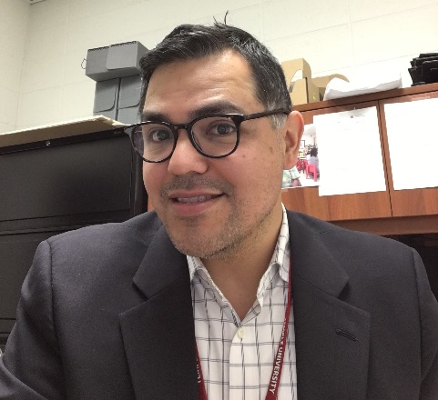
Josue Hurtado

Job title: Coordinator of Public Services & Outreach, Special Collections Research Center, Temple University Libraries

Education:
University of Michigan, School of Information, MSI (Archives and Records Management Specialization)

Candidate Statement:
Reference, access and outreach are where the rubber hits the road in the archives. It is where all of our other professional endeavors - appraisal, accessioning, processing – meet their ultimate fulfillment; the intersection between researcher and materials. In my current position as Coordinator of Public Services & Outreach, I’ve dedicated my professional life to ensuring that researchers from all walks of life have access to the rich historical materials in our collection.
I have a range of experience in archives, from appraisal and processing to reference work and archival instruction in academic library settings. This breadth of experience has given me a deep understanding of the ways that our professional practices combine to impact researchers’ ability to find and access archival materials.
I’d like to bring my experience and dedication to this section as a steering committee member. I’ve served on several other SAA committees, including chairing the Archivists and Archives of color roundtable, as well as the Pinkett and Forman award committees. My work on these committees also exemplifies my belief that we as a profession need to do more to increase outreach to traditionally under-represented and under-served groups.
I’m excited by the opportunity to work with the members of this section to advance its important work.

Work Experience:
- Coordinator of Public Services and Outreach. Special Collections Research Center. Temple University Libraries
- Project Archivist. Medical Center Archives of New York-Presbyterian/Weill Cornell Medical College
- Assistant Archivist / Acting Manager. University of California at San Francisco Archives & Special Collections
- Project Archivist. AIDS Epidemic Historical Records Project - GLBT Historical Society Museum
- Production Technician, JSTOR
- Archival Processing Assistant. Bentley Historical Library. University of Michigan
- Archival Processing Intern. Bancroft Library. University of California at Berkeley

Relevant Professional Service:
Society of American Archivists
Chair, Forman Award SAA Subcommittee, 2013-2015
Chair, Archivist & Archives of Color Roundtable, SAA, 2007-2009
Chair, Pinkett Award, SAA Subcommittee, 2008-2009
Reference, Access, and Outreach Section Teaching with Primary Sources Subcommittee, current
SAA Awards Committee, 2007-20015
Mid-Atlantic Regional Conference
Diversity and Inclusion Task Force
Delaware Valley archivists Group

Relevant Publications & Presentations:
-Provided instruction on archives and uses of primary sources to close to 80 classes of undergraduate and graduate students in three years in my current position.
-“Seeking a Solution for Managing Digital Images in the Archives”. Presented at the Society of California Archivists Annual Meeting, 4/30/2011

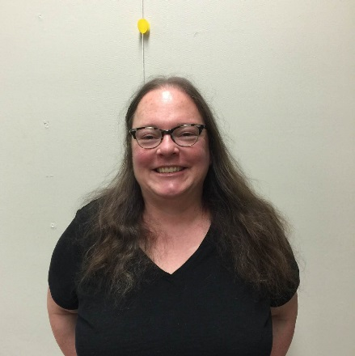
Mandy Mastrovita

Job title:
Digital Projects Librarian, Digital Library of Georgia (University of Georgia Libraries)

Education:
MFA-University of Georgia (Printmaking), 2001
MLIS-University of Alabama, 2008

Candidate Statement:
I would love the opportunity to serve RAO because the section is such a reliable source for new ideas, and has so many dynamic participants finding new ways to connect with the public and advocate on behalf of their collections. In my position at the Digital Library of Georgia, one of my responsibilities includes promoting the collections and relationships that we cultivate with statewide project partners. RAO has repeatedly provided guidance in this area. I am currently the co-chair of the Society of Georgia Archivists Georgia Archives Month committee, which promotes the value of Georgia’s historical records, publicizes the ways historical records enrich our lives, and recognizes those who maintain our communities’ historical records. I have also recently co-authored the comic strip "Beyond The Elevator" which appears in the SAA's Committee on Public Awareness (COPA) ArchivesAWARE! blog. Serving these committees has given me the opportunity to collaborate with enthusiastic people with exciting ideas about access and outreach that I would love the opportunity to share with RAO.

Work Experience:
Digital Projects Librarian, Digital Library of Georgia (2010-present); Digital Production Librarian, Clemson University Libraries (2008-2010); Digital Imaging Coordinator, Digital Library of Georgia (2006-2008); Metadata Specialist, Digital Library of Georgia (2004-2006); Director of PR, Marketing and Special Programs, Atlanta Contemporary Art Center, Atlanta, GA (2003); Associate Director Nexus Press, a division of the Atlanta Contemporary Art Center, Atlanta, GA (2000-2003)

Relevant Professional Service:
Society of Georgia Archivists, Georgia Archives Month Committee co-chair (2016); Society of Georgia Archivists, Georgia Archives Month Committee (2015); Society of Georgia Archivists, Local Arrangements Committee (2014); Society of Georgia Archivists, Program Committee (2012); Society of American Archivists, Member-at-large, Visual Materials Steering Committee (2011-2013); Member, SAA (2010-present); Member, Society of Georgia Archivists (2010-present); Member, Georgia Library Association (2013-present);

Relevant Publications & Presentations:
2016-Beyond the Elevator cartoon strip (co-created with Jill Severn). ArchivesAWARE! Blog, SAA's Committee on Public Awareness (COPA). (https://archivesaware.archivists.org/2016/02/08/beyond-the-elevator-no-1/,
https://archivesaware.archivists.org/2016/03/14/beyond-the-elevator-no-2/ ,
https://archivesaware.archivists.org/2016/04/19/beyond-the-elevator-no-3/)

2015- Book review, Rights in the Digital Era, edited by Menzi L. Behrnd-Klodt and Christopher J. Prom (Chicago: Society of American Archivists, 2015. 238 pp.) in Provenance: Journal of the Society of Georgia Archivists, 2015 (Volume XXXIII), pp.163-165.
2012 -"Newsfilm Coverage of the Civil Rights Movement Available Online in the Civil Rights Digital Library" in Views (Society of American Archivists Visual Materials Section newsletter), July, 2012 (Volume 26, Number 2). Available at http://saavms.org/wp-content/uploads/2015/07/Views_July_2012.pdf [accessed May 9, 2016].
2010 -"Collaborative-Centered Digital Curation: A Case Study at Clemson University Libraries (co-authored with Emily Gore) in Digitization in the Real World: Lessons Learned from Small to Medium-Sized Digitization Projects, Kwong Bor Ng (Queens College, CUNY) and Jason Kucsma (Metropolitan New York Library Council), eds. Published by the Metropolitan New York Library Council (METRO) as a book (http://www.lulu.com/spotlight/metropubs) [accessed May 9, 2016]. Article available online at: http://metroblogs.typepad.com/files/ditrw_30.pdf [accessed May 9, 2016].

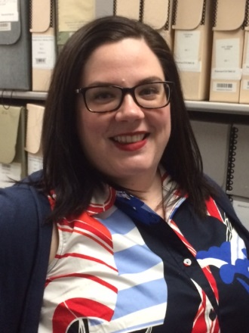
Julie Porterfield
Job title: Instruction & Outreach Archivist, Penn State University Libraries

Education:
MA, Global History with a focus on Women, Seton Hall University
MLIS, University of Pittsburgh

Candidate Statement:
Since last year's Annual Meeting, I have transitioned into a postion in which my primary responsibilities include instruction and outreach. As I continue to build my skills in these areas, RAO provides an environment in which I can be around like-minded archivists whose passions and responsibilities are reference, access, and outreach related. I believe the best way to learn from my colleagues, and to share my knowledge with the group, is to increase my involvement through service.
I have a particular interest in teaching with primary sources, and I'm serving on the TPS Unconference Committee for this year's Annual Meeting. I would also like to bring my perspective as a feminist pedagogue to the group, and begin a conversation about how archivists can incorporate feminist pedagogy into their curricula. However, I am eager to learn new skills, and serve the group through the Steering Committee where I am most needed.

Work Experience:
- 2009-2011 Seton Hall University Archives Graduate Employee
- 2012-2013 Coal & Coke Heritage Center at Penn State Fayette, Part-time Employee
- 2013-2015 Coal & Coke Heritage Center at Penn State Fayette, Archivist
- 2015-Present Instruction & Outreach Archivist, Penn State University Libraries
Relevant Professional Service:
I'm currently serving on the TPS Unconference Committee for this year's Annual Meeting. Specifically, I'm serving on the Program sub-committee, and planning a session on "Lesson Planning with Primary Sources.” The Unconference Committee has been a great start to getting involved with RAO, and I'm seeking to increase my involvement by running for the Steering Committee.

Relevant Publications & Presentations:
"Transforming C-R: Primary Sources as Examples of the Relationship Between Documentation, Oppression, Power, and Collective Memory in Feminist Pedagogy"
Paper Presentation at CUNY's Feminist Pedagogy Conference 2015
“Teaching Primary and Secondary Sources with Instructional Librarians: An Exercise in Advocacy.” Poster Presentation at SAA Annual Meeting 2015

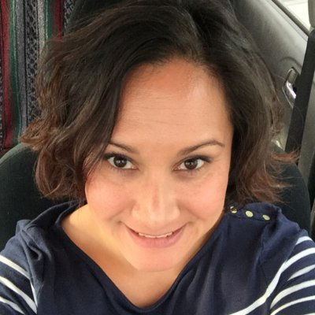
Rachel Seale
Job title: Outreach Archivist, Iowa State University

Education: MSLIS with an archives concentration, Simmons College, January 2006

Candidate Statement:
I am interested in a leadership position in the Reference, Access and Outreach Section of Society of American Archivists because of my continuing professional interest in making collections accessible to people and telling people about the cool things we do. At the University of Alaska Fairbanks, where I worked from 2009-2015, I developed the outreach programming for the archives and always considered that aspect of my job the fun stuff. The focus of my current position at Iowa State University is providing leadership with our department's reference and outreach activities so now the fun stuff is a much bigger part of my position. I have experience with leadership positions in regional organizations and have just started in the past few years to become more involved with SAA. RAO is an active exciting section and I would contribute my enthusiasm for the profession and for reference, access and outreach issues.

Work Experience:

Outreach Archivist (January 2016-present) at Iowa State University; Archivist (September-December 2015), Associate Archivist (December 2011-September 2015), and Assistant Archivist for Reference (December 2009-December 2011) at University of Alaska Fairbanks; Reference Librarian at Forbush Memorial Library in Westminster, MA (July 2006-August 2008).

Relevant Professional Service:
Society of American Archivists
2013-2014 Security Roundtable secretary
2014-2015 Security Roundtable junior co-chair
2015-2016 Security Roundtable senior co-chair
2016 member of Issues and Advocacy (I&A) Roundtable’s On-Call Research Team (#2)
Northwest Archivists Association
2011 Annual Meeting Program Committee member
2013-2015 Board member and state representative
2014 Nominating Committee chair
Alaska Library Association
2014-2015 Special Libraries Roundtable chair
2015 Conference chair/coordinator

Relevant Publications & Presentations:
Northwest Archivists Association
- 2014 Conference presentation, "Archives Month Extravaganza," lightning talk, 30 May 2014, Spokane, WA
- 2015 Conference presentation, "Corralling Digital Chaos: Case Studies in Digital Preservation from the Far North," 28 May 2015, Denver, CO
Alaska Library Association
- 2014 Conference presentation, "Digital Preservation Planning: Just Do It!" 28 February 2014, Anchorage, AK
Alaska Historical Society
- 2011 Conference, Presentation, “Down by the river: A short history documenting the use of Alaska’s Rivers” 23 September 2011, Valdez, AK
- 2013 Conference Presentation, “Intersection of Collections” 28 September 2013, Haines AK
- 2014 Conference presentation, "Gateway to our Archives," 2 October 2014, Seward, AK

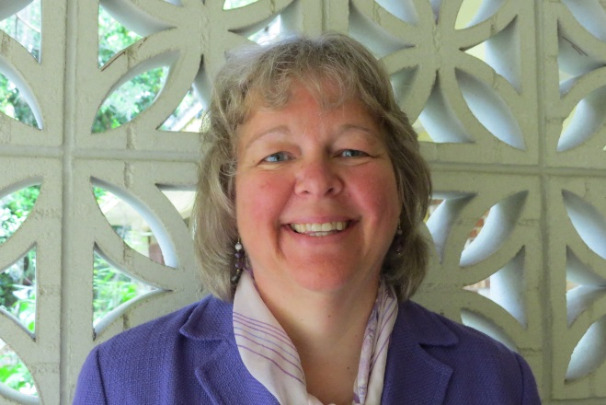
Florence Turcotte

Job title:
Literary Manuscripts Archivist (Associate University Librarian), Department of Special and Area Studies Collections, George A. Smathers Libraries, University of Florida, Gainesville

Education: M.L.S., University of South Florida

Candidate Statement:
Since the very beginning, my career in archives has been all about Reference, Access and Outreach. I have worked to improve research services in my department and in the Libraries at the University of Florida in general. I have written, presented and published in diverse venues about our collections and services throughout my career. I have been a member of RAO for 11 years, and am ready to take on a leadership role in the Section. Thank you for your support!

Work Experience: Library Technical Assistant, University of Florida Libraries, 1997-2005; Research Services Archivist, 2005-2008; Literary Manuscripts Archivist, 2008-present (all at University of Florida)

Relevant Professional Service:
Society of American Archivists, 2005-present.
Manuscripts Repositories Section, 2005-present. Steering Committee, 2012-2014. Discussion facilitator, 2011 and 2013 section meeting.
Reference, Access and Outreach Section, 2005-present. Task Force on Teaching with Primary Sources, 2011-present.
LAGAR Roundtable, 2005-present. Co-Chair, 2011-2013. Bylaws Task force chair, 2010. Steering Committee, 2009-present.
Society of Florida Archivists, 2005-present.
Vice-President, 2012-2013, Director, 2009-2012 Treasurer, 2015-present. Chair, Nominating Committee 2008-2009. Chair, SFA Annual Meeting Host Committee, 2009.

Relevant Publications & Presentations:
Publications
“The Allure of the Archives” (Book Review). By Arlette Farge, translated by Thomas Scott-Railton. American Archivist 77:2 (Fall/Winter 2014)

“One Community, One Story“. Chapter in Librarians as Community Partners: An Outreach Handbook. Edited by Carol Smallwood. (Westport, Conn.: Libraries Unlimited, 2009).

“Partnering with a Local Park or Historical Agency“. Chapter in Librarians as Community Partners: An Outreach Handbook. Edited by Carol Smallwood. (Westport, Conn.: Libraries Unlimited, 2009).

“Outreach in Special Collections Librarianship”. Chapter in Academic Library Outreach: Beyond the Campus Walls. Edited by Nancy Courtney. (Westport, Conn.: Libraries Unlimited, January 2009).

Public Services in Special Collections. SPEC Kit, with John Nemmers. (Washington, D.C.: Association of Research Libraries, November, 2006).

Presentations
Presentation: "Talking Objects, Global Voices: Collecting Florida", lecture series sponsored by the Center for the Humanities in the Public Sphere, Smathers Library, March 13, 2016.
Presentation: "Preview of Top-Shelf Lectures", at Oak Hammock, Gainesville. Developed and presented an illustrated overview of Special and Area Studies Collections in order to inform the residents about possible future topics for their Institute for Learning in Retirement lecture series. October 28, 2015.
Tour guide and presenter, History Bus Tour of the Marjorie Kinnan Rawlings Historic State Park, hosted by the Matheson History Museum, Gainesville. October 10, 2015.
Conference paper: "Collaboration in the Federal Writer's Project: Stetson Kennedy and Zora Neale Hurston". As part of a panel entitled "More than the Man who Busted the Klan: The Legacy of Stetson Kennedy". Gulf South History & Humanities Conference, Natchez, MS. October 3, 2015.
Conference paper: "Selling Wholesomeness: Images of Women from the Florida Citrus Industry". As part of a panel entitled "You've come a Long Way, Baby: Images of Women in Advertising". Society of American Archivists, Cleveland, OH, August 21, 2015.
Panel Presentation at the performance of Invasion of Privacy play at Santa Fe College Fine Arts Center. Topic: “Marjorie Kinnan Rawlings and the Cross Creek Trial”. June 18, 2015.

Paper: “Caught at the Still: Marjorie Kinnan Rawlings and the Florida Moonshiners.” 28th Annual Conference of the Marjorie Kinnan Rawlings Society, Florida Southern College, Lakeland, March 28, 2015.

Paper: Florida Icons: Marjorie Kinnan Rawlings, Zora Neale Hurston, and Stetson Kennedy”, with Sandra Parks at the 27th Annual Conference of the Marjorie Kinnan Rawlings Society, University of Florida Hilton, Gainesville, March 22, 2014.

Paper: “Marjorie, Zora, and Stetson: How Three 1930s Writers Depicted Life in the South”. Invited presentation with Sandra Parks, South Atlantic Modern Language Association (SAMLA) 85th Annual Meeting, Atlanta,GA, November 9, 2013.

Paper/Panel Discussion: “Assessing Archival Instruction in Special Collections”. Panel entitled: Engaged! Innovative Engagement and Outreach and Its Assessment, Society of American Archivists Annual Meeting, Chicago, August 25, 2011.

Paper/Panel Discussion: “Changing Lives: Evaluating Encounters with Undergraduates in the Archives”. RBMS (Rare Books and Manuscripts) Conference, Baton Rouge, June 23, 2011.

Presentation and panel moderator: “Archives, Outreach and Advocacy”. Society of Florida Archivists Annual Meeting, Boca Raton, June 8, 2007.

Other Outreach
Magazine interview with Lauren Groff, free-lance writer. Feature article, “The Lost Yearling: An American Classic Fades away”. Harper’s Magazine, January 2014. http://harpers.org/archive/2014/01/the-lost-yearling/

Newspaper interview with Jeff Klinkenberg, correspondent. Feature article: “The Archivist”, Tampa Bay Times February 5, 2012. http://www.tampabay.com/features/humaninterest/uf-archivist-preserves-priceless-manuscripts-of-marjorie-kinnan-rawlings/1213385

Video/Radio Interview with Ben Brotemarkle about Zora Neale Hurston in Brevard County, FL. Aired on Florida Frontiers 108 radio program, National Public Radio (NPR), Historic Rosseter House Museum - FL Historical Society, Eau Gallie, FL, October 21, 2011. Video debuted in May 2012, and distributed to PBS affiliates nationwide in 2013.
http://myfloridahistory.org/frontiers/shows

Radio Interview: “On Location: The Central Florida of ‘The Yearling’”. Interview by Greg Allen, aired on All Things Considered, National Public Radio (NPR), June 21, 2011.
http://www.npr.org/2011/07/21/138561573/on-location-the-central-florida-of-the-yearling.

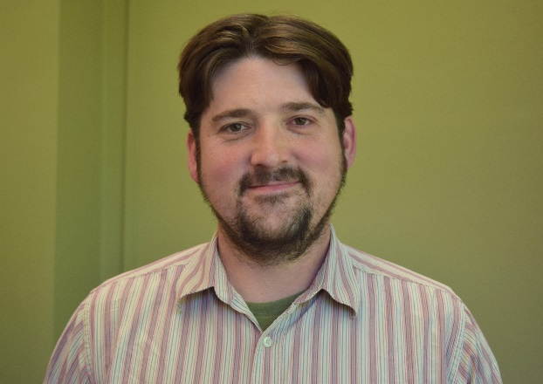
Joshua Youngblood

Job title: Research and Outreach Service Librarian, Special Collections, University of Arkansas Libraries

Education:
Certification from the Academy of Certified Archivists, 2014.
Completion of Coursework for Ph.D. in American History, Florida State University (ABD), 2007.
MA in History, Florida State University, 2004.

Candidate Statement:
The work of RAO is a tremendous resource for professional archivists involved in the public side of our work, servicing collections, working with the community, and assisting researchers. Whether for those just beginning in the profession or seasoned professionals, RAO can offer ideas and practical solutions, as well as make the case for the importance of working with the public to the profession as a whole and all our constituents. Since joining SAA in 2011, I have taken part in RAO workshops and committees, and I have served on programming committees for both SAA and the Society of Southwest Archivists. I have presented research on accessibility, the social significance of research services, and the integral role of outreach for institutional missions at RBMS and ICA. RAO has many directions to choose from and issues to engage in, such as how to encourage more collaboration with local organizations for education and digital resource, opportunities for research and outreach through community archiving, and how archives grapple with social issues such as bridging the digital divide and promoting archives as essential civic resources. I believe RAO can enhance outreach to K-12 students, building on the success of History Day initiatives, and then go further in order to utilize archives to increase research skills and various literacies and subject competencies for students before they go to college. I would like to help RAO participate in the larger discussions of advocacy in the profession and use the opportunity to provide guidance on how to demonstrate the impact of research, access, and outreach on effective archival advocacy. I look forward to serving however I can.

Work Experience:
- Archives Historian, Florida Memory Program, State Library and Archives of Florida. 2008-2011.
- Information Specialist, Division of Cultural Affairs, Florida Department of State. 2008.
- Program Assistant, Florida Main Street Program, Florida Bureau of Historic Preservation. 2007-2008.
- Graduate Assistant, Dean of Arts and Sciences, Florida State University, 2004-2007.
- Technical Writer, Patient Care Technologies, Atlanta, GA, 2002-2004.
- Graduate Assistant, Archives on World War II and the Human Experience, Florida State University Department of History. 2000-2001, 2004.

Relevant Professional Service:
Professional organizations:
- Society of Southwest Archivists 2017 Local Arrangements Chair. Appointed July 2015.
- Society of American Archivists 2015 Conference Program Committee. Appointed August 2014.
- Society of Southwest Archivists 2014 and 2015 Program Committees.
For the University of Arkansas :
- Academic Integrity & Code of Student Conduct Committee, University of Arkansas, August 2015 – Present.
- All University Academic Integrity Board, University of Arkansas, 2011 – 2014. Chair of Tuesday Group, 2012 – 2014.
University of Arkansas Libraries:
- User Experience Group, 2015 – Present.
- Web Services Committee, 2011 – Present.
- Diversity Committee, Fall 2011 – Spring 2015.

Relevant Publications & Presentations:
Publications:
“Following a Trail of Tin Cans: Archival Engagement, ‘Tin Can Tourism,’ and the Internet life of Historical Images.” Archival Issues: Journal of the Midwest Archives Conference, Vol. 36, no. 2 (August 2015), 36-53.
Of Passover and Pilgrimage: The Natchez Jewish Experience. Curated by Marcie Cohen Ferris. Temple B’nai Israel, Natchez, Mississippi. The Journal of Southern Jewish History, v. 18 (Fall 2015), 208-213. Exhibit review.
“Benjamin J. (B. J.) Rosewater (1857–1943).” Encyclopedia of Arkansas History & Culture. September 2015.
“John Stubblefield (1945-2005).” Encyclopedia of Arkansas History & Culture. January 2015.
“BAD Times and Good Stuff at the University of Arkansas: University Archives, Student Access, and Promoting Diversity in Special Collections.” Archival Practice, Vol. 1, no. 2 (October 2014). With Amy Allen. I was lead author responsible for 60% of the article.
“Arthur Brann Caldwell (1906-1987).” Encyclopedia of Arkansas History & Culture. January 2014.
“Choate Family Discovers Father’s Letters.” Southwestern Archivist v. 36, no. 23 (August 2013), p. 15.
“Nathaniel Robadeau Griswold (1901–1991).” Encyclopedia of Arkansas History & Culture. January 2013.
“Legislation Creating Land Grant Colleges is 150 years old.” Arkansian: Newsletter of the University of Arkansas Libraries Special Collections Department. (Fall 2012).
Home Demonstration and Extension Service Records: Documenting the Services to Rural Families in Arkansas.” The Arkansian: Newsletter of the University of Arkansas Libraries Special Collections Department (Spring 2012).
“Arkansas and Captivity during World War II.” The Arkansian: Newsletter of the University of Arkansas Libraries Special Collections Department (Fall 2011).
“Cooperatives, Consumer.” American Countercultures: An Encyclopedia of Nonconformists, Alternative Lifestyles, and Radical Ideas in U.S. History, ed. Gina Misiroglu. Armonk, NY: Sharpe Reference, 2009.
“Cooperatives, Producer.” American Countercultures: An Encyclopedia of Nonconformists, Alternative Lifestyles, and Radical Ideas in U.S. History, ed. Gina Misiroglu. Armonk, NY: Sharpe Reference, 2009.
From Rights to Economics: The Ongoing Struggle for Black Equality in the U.S. South by Timothy J. Minchin. The Florida Historical Quarterly, Vol. 86, No. 2 (Fall 2007), 257-260. Book review.
“‘Haven’t Quite Shaken the Horror’: Howard Kester, the Lynching of Claude Neal, and Social Activism in the South during the 1930s.” Florida Historical Quarterly, Vol. 86, no. 1 (August 2007), 3-38.
Losing it All to Sprawl: How Progress Ate My Cracker Landscape by Bill Belleville, in “H-Net, H-Florida: Study of Florida History and Culture” (July 2006), http://www.h-net.org/~florida/. Book review.
Select Presentations:
“Academic Archives and Public Engagement: Connecting Collections with the Communities they Serve.” Conference paper, International Council on Archives Annual Conference, Reykjavik, Iceland. September 28, 2015.
“Surviving Confinement: Health Care and Community for Arkansas’s Japanese-American Internees.” Conference paper, Arkansas Historical Association Annual Meeting, West Memphis, Arkansas. April 11, 2015.
“‘Freedom is Everybody’s Business’: Using Multi-Faceted Outreach to Draw Student Attention to Local Archival Collections on the Civil Rights Movement of the 1960s.” Conference poster presentation, Rare Books and Manuscripts Section of the American Library Association Pre-Conference, Las Vegas, Nevada. June 26 - 27, 2014.
“Hidden Learning: the Student Experience in Special Collections.” With Tim Nutt, Catherine Wallack, and Krista Oldham (not present). Conference panel presentation, Society of Southwest Archivists Annual Meeting, New Orleans, LA. May 30, 2014.

“Beyond the Barbed Wire: Nat Griswold and the Community Activities Section at the Rohwer Japanese American Relocation Center.” Conference paper, Arkansas Historical Association Annual Meeting, Washington, Arkansas. April 4, 2014.
“Dedicated and Rededicated: Architecture and the Archives at the University of Arkansas.” Conference presentation. Archives 2013 Joint Meeting of Society of American Archivists and Council of State Archives, Architectural Archive Roundtable. New Orleans, Louisiana, August 14, 2013.
“‘Broke of Sucking Eggs’: the Murder of Hugh Johnson, Race, and Law in Post-War Pulaski County, Arkansas.” Conference paper. Arkansas Historical Association Annual Conference, Helena-West Helena, Arkansas, April 12, 2013.
“Tin Can Tourism in Florida and Engaging the Public through Digital Exhibiting.” Conference paper. 2013 Popular Culture Association/American Cultural Association Annual Meeting, Washington, DC. March 27, 2013.

“Usability Testing on Another Dime (and $100).” Conference panel presentation. Arkansas Library Association Annual Meeting. Springdale, Arkansas. November 17, 2012. With Beth Juhl, Sarah Spiegel, and Molly Boyd (not present).

