Agenda VI.D.4.

Society of American Archivists
Council Meeting
November 2022
Hybrid Meeting

Staff Report: Publications Program Overview
August 2022–November 2022
(Prepared by Abigail Christian)

I. QUARTER HIGHLIGHTS
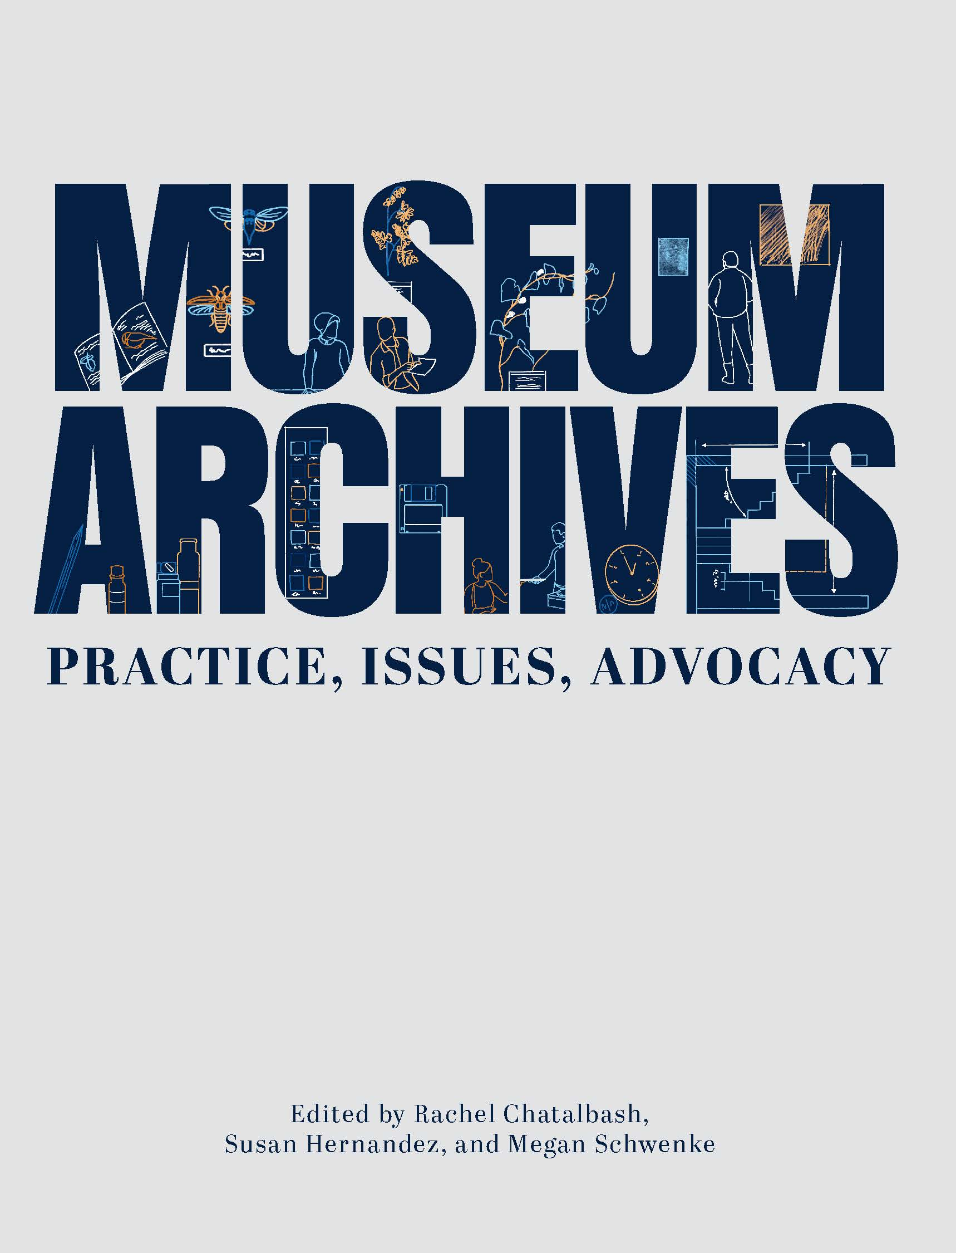
- New books: Museum Archives: Practice, Issues, Advocacy, edited by Rachel Chatalbash, Susan Hernandez, and Megan Schwenke, and Born-Digital Design Records, edited by Samantha Winn and part of the Trends in Archives Practice Series, are at the printer and will arrive in SAA’s Bookstore in November and October, respectively.
- The Publications Board approved a proposal for Radical Visions: New Perspectives in Special Collections Curatorship, edited by Jillian Cuellar and Agnieszka Czeblakow; contract is underway.
- The American Archivist Editorial Board is planning a special section on Middle East and North Africa Archives for issue 86.2 (Fall/Winter 2023), led by guest editors and Board members Sumayya Ahmed and Rebecca Hankins. The call for submissions ends February.
- Publications is hiring a Program and Editorial Coordinator who will coordinate production for American Archivist and the Archives in Context podcast as well as other publishing projects and will assist governance in section communications. The interview process is underway with a goal to fill the position in November.
II. BOOKS
- Publications Board
- SAA staff Abigail Christian has disseminated performance evaluation forms for Publications Editor Stacie Williams to the Pubs Board, Council liaison, past president, executive director, director of publishing, and recent and current authors. Feedback will be compiled and submitted to the Council for review.
- The Publications Board met virtually on August 5; its next meeting is October 28. The Board is currently surveying past SAA books, topics, and authors to assist in planning future projects.

- Project Updates
- With the Printer!
- Trends in Archives Practice Series: Born-Digital Design Records edited by Samantha Winn.
  - “Module 24: Navigating the Technical Landscape of Born-Digital Design Records” by Kristine Fallon (lead author), Aliza Leventhal, Zach Vowell;
  - “Module 25: Emerging Best-Practices for Born-Digital Design Records” by Jody Thompson (lead author), Euan Cochrane, Aliza Levanthal, Laura Schroffel, Emily Vigor;
  - “Module 26: Case Studies in Born-Digital Design Records” by Aliza Leventhal (lead author), Zach Vowell, Mireille Nappert, Stefana Breitwieser, Alex Jokinen.
  - Museum Archives: Practice, Issues, Advocacy, edited by Rachel Chatalbash, Susan Hernandez, and Megan Schwenke.
- In Production
  - Archival Futures Series (SAA/ALA): Decolonial Archival Futures by Krista McCracken and Skylee-Storm Hogan.
- Manuscripts in Process
1. Teaching Primary Source Research Skills by Julie Thomas.
2. 410 Measurable Learning Outcomes for Primary Source Literacy by Robin Katz.
3. The Solo Archivist: Succeeding in a Small Repository by Christina Zamon.
4. Archival Fundamentals Series III, Volume 6: Selecting and Appraising Archives and Manuscripts by Margery Sly.
5. Archival Fundamentals Series III, Volume 7: Introducing Archives and Manuscripts by Peter J. Wosh and Michael J. Kurtz.
6. Making Our Mark: How Archivists of Color Changed the Landscape of SAA edited by Steven Booth and Barrye Brown.
7. Remedy, Rectify, and Reconstruct: Case Studies in Inclusive and Reparative Archival Description Efforts, edited by Katherine M. Wisser and Elena C. Hinkle
8. Archival Futures Series (SAA/ALA): Archives, Time Travel, and Pop Culture by Lynne M. Thomas and Katy Rawdon.
9. Archival and Special Collections Facilities: Guidelines for Archivists, Librarians, Architects, and Engineers, Revised Edition, by Michele Pacifico.
- Proposals Approved and Contract in Progress
- Radical Visions: New Perspectives in Special Collections Curatorship, edited by Jillian Cuellar and Agnieszka Czeblakow.

- Open-Access Case Study Series
  - The Archival Ethics Case Studies Series, which last published a case in 2015, is revitalizing the series with a new call for submissions released in August.

II. American Archivist
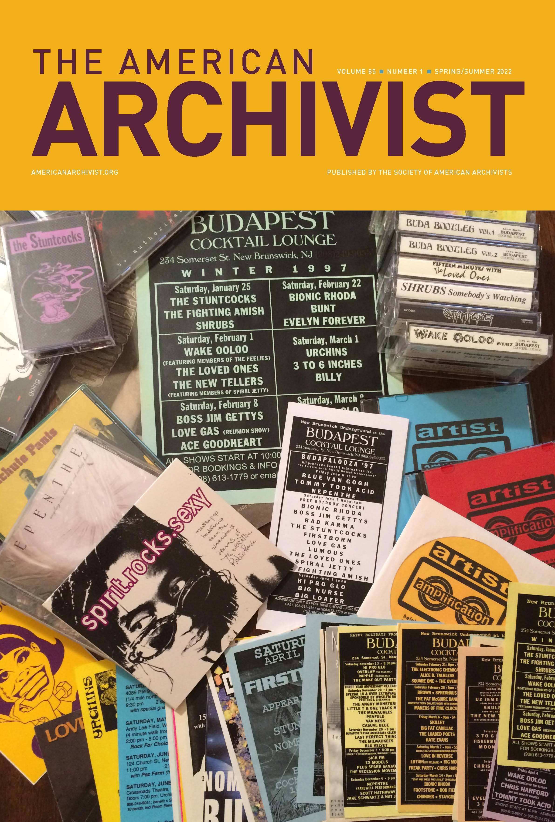
- New Issue of American Archivist
Issue 85.1 (Spring/Summer 2023) was published in June and features the 2021 presidential address from Rachel Vagts, the 2021 Theodore Pease Award-winning article, 12 articles, and three book reviews. Of the 31 contributors, 22 are first-time contributors to the journal. Issue 85.2 is in production.
- Special Section on Middle Eastern and North African Archives
Board members Sumayya Ahmed and Rebecca Hankins are serving as guest editors for a special section on Middle East and North Africa archives, slated for issue 86.2 (Fall/Winter 2023). The
call for submissions is open with a deadline of February 2023.
- A*CENSUS Dissemination Conversations
American Archivist Editor Amy Cooper Cary and SAA staff Abigail Christian are in conversation with the A*CENSUS Dissemination Committee to discuss publication and distribution of A*CENSUS content in American Archivist. The initial survey data and reports will be published in a branded section in 86.1 (Spring/Summer 2023). Following issues will continue to feature analysis of the data via an open call for archivists to engage with the data.
D. Editorial Board
Dr. Shirley Carvalhedo (University of Baltimore) is the newest Board member, who is serving in the capacity of the Board’s international member. The Board’s next meeting is November 18.
E. New Content on Reviews Portal
The Reviews Editors Rose Buchanan and Stephanie Luke have been actively publishing new content in unique formats on the Reviews Portal (15 new reviews in 2022!) and cross-promoting portal content in issues 85.1 and 85.2. Buchanan and Luke are also developing a series of reviews that engage with influential articles by archivist and SAA Fellow John Fleckner. This series of 10-12 “intergenerational conversations” will be published on the portal throughout the year and include an introduction to Fleckner’s work written by Fleckner and Rand Jimerson.

III. ARCHIVAL OUTLOOK
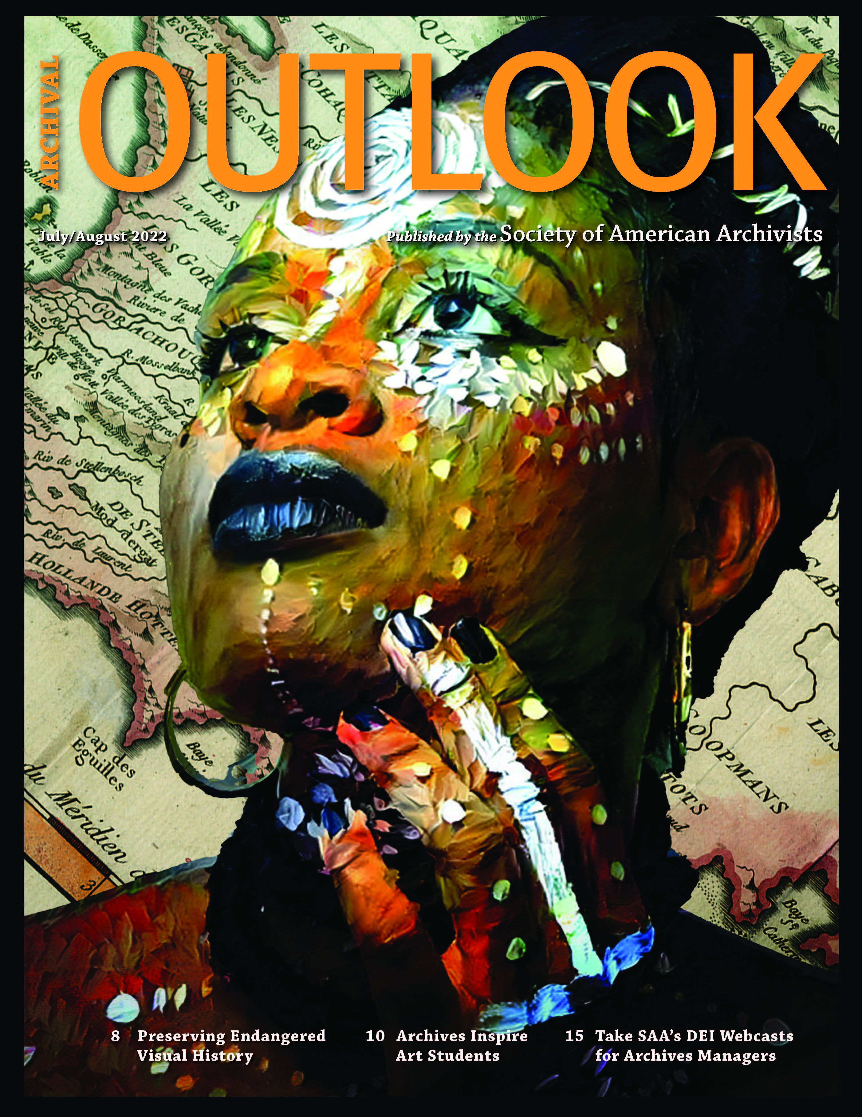
As part of pursuing DEIA content according to SAA’s Strategic Plan, featured articles in the July/August and September/October issues include:
- “Expanding the Reach of the Cosmic Dancer: Inter-Campus Collaboration Provides Access to the Works of Rev. Dr. Mitsuo Aoki,” by Helen Wong Smith and Janel Quirante
- “Archives Inspire: Creating Primary Source Instruction for Art Students at University of Texas at Arlington” by Evan Spencer (from which the cover art to the right comes from)
- “Celebrating an Underserved Neighborhood through Story Fest” by Anna Trammell, dindria barrow, and Spencer Bowman
- “One Book, One Campus, Two Collections” by Lisa Mix.
Nearly all of these authors are publishing for the first time with SAA.
IV. DICTIONARY OF ARCHIVES TERMINOLOGY
The Dictionary of Archives Terminology continues to be updated to reflect improvements to definitions based on user feedback as well as introduce new terminology. The nine-member working group meets every Wednesday via Zoom to define terminology and draft the Word of the Week. New social media posts on SAA’s Instagram has also increased engagement with Word of the Week and SAA’s account, accruing 450 new followers since May.
V. OUTREACH & PROMOTION
A. Virtual Event Planning
- Write Away Forum on SAA Publication Opportunities (November 17)
This annual forum will highlight various publishing outlets and answer queries on what and how to submit content, topic trends and new directions, and how to connect with editors after the webinar. Panelists include Publications Editor Stacie Williams, American Archivist Editor Amy Cooper Cary, American Archivist Reviews Editors Rose Buchanan and Stephanie Luke, Archival Futures Series Co-editor Bethany Anderson, Julia Pillard on Archival Outlook, and Rosemary Pleva Flynn on Dictionary of Archives Terminology. Sponsored by the SAA Publications and American Archivist Editorial Board.
- One Book, One Profession Panel Discussion Fall 2022 (date TBD)
Cheryl Oestreicher’s Waldo Gifford Leland Award-winning book Reference and Access for Archives and Manuscripts (Vol. 4, Archival Fundamentals Series III, SAA, 2020) is the 2022 selection for this reading initiative. The book is particularly relevant as archivists consider issues of access during different stages of the COVID-19 pandemic, and the book explores barriers for various users and ways to remove them. Sponsored by the SAA Publications Board.

- Archives in Context Podcast
The team has started Season 7 with two episodes forthcoming, featuring brief interviews with conference attendees and an interview with SAA author Cheryl Oestreicher to be released in November.

C. Reviews of SAA Books in the Professional Literature
  - Advancing Preservation of Archives and Manuscripts (SAA, 2020)
    - Journal of Western Archives Vol 13,
    - Journal of Australian Library and Information Association 71.1, and
    - American Archivist 84.2
  - “All Shook Up”: The Legacy of Terry Cook (SAA, 2020)
    - Journal of Western Archives Vol 13
  - Archival Accessioning (SAA, 2021)
    - Journal of Western Archives Vol 13
  - Archival Virtue: Relationship, Obligation, and the Just Archives (SAA, 2021)
    - Journal of Western Archives Vol 13 and
    - American Archivist 85.1
  - Defining a Discipline: Archival Research and Practice in the 21st Century (SAA, 2020)
    - Journal of Australian Library and Information Association 70.4

- Book Sales & Promos
- The Annual Meeting book sale was held online throughout August. This year 23 titles were part of the conference promotion, discounted at 10% to 50% off select titles. A total of 224 books were sold and generated a gross revenue of $5,087.97.
- SAA communications promoted the book Engagement in the Digital Era (2020) as part of American Archives Month in October.

- Renewed Vendor Partnerships
  - Updated the book titles and issues of American Archivist and Archival Outlook filed with the Library of Congress. All back issues are now on file and new publications will be automatically sent to the LOC. This was last done in 2012.
  - Updated list of book titles in the Copyright Clearance Center, which manages payment for institutions using portions of SAA’s books. This was last done in 2014.
VI. SAA Marketing & Communications
- ARCHIVES*RECORDS 2022 Promotion
Drafted email communications around the schedule, follow-up survey, and post-conference recordings for the Annual Meeting and worked with on-site photographer.

- SAA-wide Content and Content Calendar
Coordinated ongoing content calendar for email campaigns and social media for association-wide news.

- Committee on Public Awareness (COPA)
Promoted communications for American Archives Month and #AskAnArchivist Day on October 12. Assisted COPA with takeovers on social media. Began planning the annual “A Finding Aid to My Soul” storytelling event. Pillard began serving as staff liaison to COPA.

- SAA Statements
Drafted and promoted communications for AOTUS nominee and committee hearing Dr. Colleen J. Shogun and disaster relief resources for archives.

