Agenda VI.D.4.

Society of American Archivists
Council Meeting
August 2022
Hybrid Meeting

Staff Report: Publications Program Overview
May 2022–August 2022
(Prepared by Abigail Christian)

I. QUARTER HIGHLIGHTS
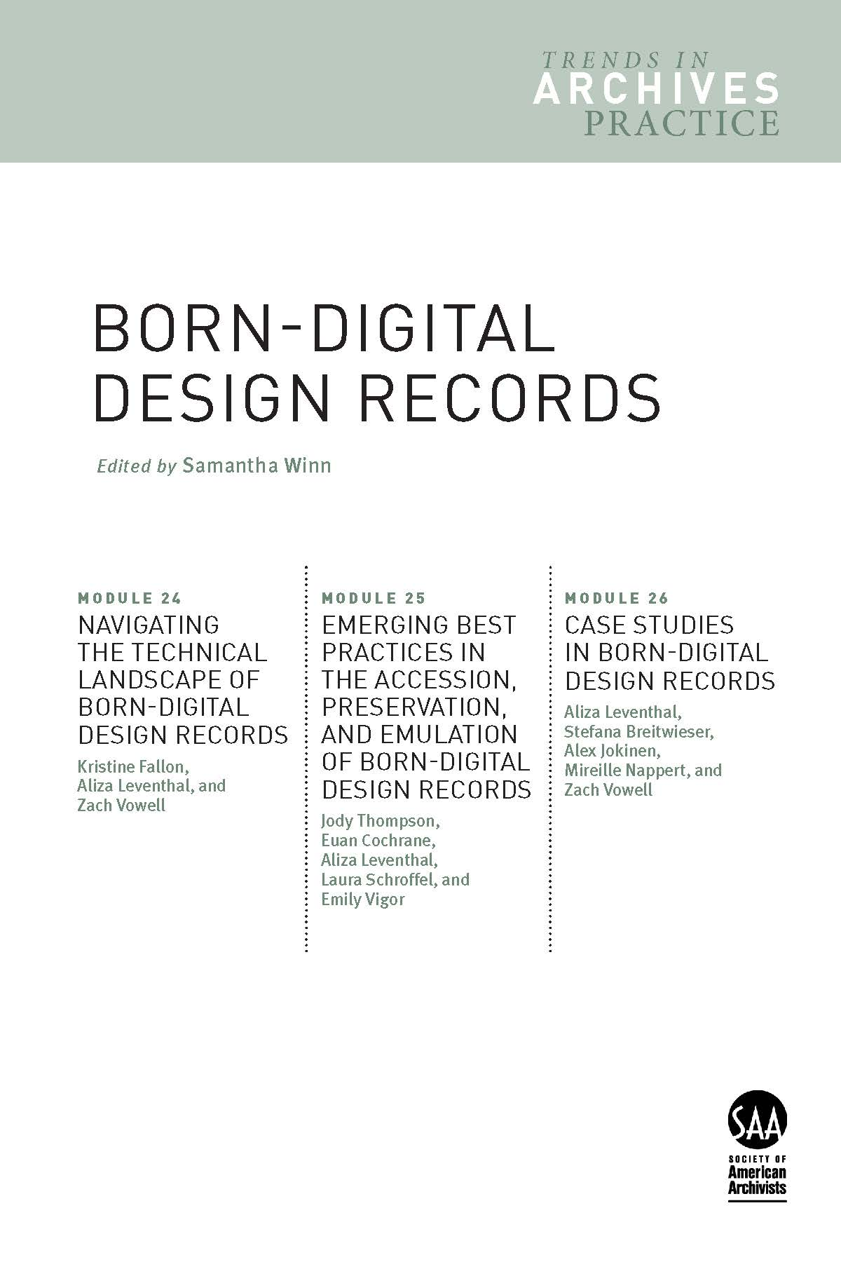
- New book: Born-Digital Design Records, edited by Samantha Winn and part of the Trends in Archives Practice Series, is at the printer and will arrive in SAA’s Bookstore in September.
- The Publications Board approved a proposal for Remedy, Rectify, and Reconstruct: Case Studies in Inclusive and Reparative Archival Description Efforts, edited by Katherine M. Wisser and Elena C. Hinkle. Contract in progress.
- The American Archivist Editorial Board is planning a special section about Middle East and North African Archives for issue 86.2 (Fall/Winter 2023), led by guest editors and Board members Sumayya Ahmed and Rebecca Hankins. The call for submissions was published in July.
- Archives in Context podcast has added transcripts to episodes in Season 6 to assist in accessibility. Past episodes will continue to be likewise updated.
- The Annual Meeting Book Sale is ongoing throughout the month of August, featuring 23 titles offered at 10% to 50% off.
- SAA staff Julia Pillard is three months into her position as the Marketing and Communications Specialist. During that time, she has collaborated with staff to create a robust editorial calendar of association-wide content for email campaigns and social media.
II. BOOKS
- Publications Board Meetings
The Publications Board met virtually on April 29; its next meeting is August 5. The Board is currently focused on assessing two new book proposals and surveying past SAA books, topics, and authors to assist in planning future projects.

- Project Updates
- With the Printer!
- Trends in Archives Practice Series: Born-Digital Design Records edited by Samantha Winn.
“Module 24: Navigating the Technical Landscape of Born-Digital Design Records” by Kristine Fallon (lead author), Aliza Leventhal, Zach Vowell;
“Module 25: Emerging Best-Practices for Born-Digital Design Records” by Jody Thompson (lead author), Euan Cochrane, Aliza Levanthal, Laura Schroffel, Emily Vigor;
“Module 26: Case Studies in Born-Digital Design Records” by Aliza Leventhal (lead author), Zach Vowell, Mireille Nappert, Stefana Breitwieser, Alex Jokinen.
- In Production
  - Museum Archives: Practice, Issues, Advocacy, edited by Rachel Chatalbash, Susan Hernandez, and Megan Schwenke.
- Manuscripts in Process
1. Archival Futures Series (SAA/ALA): Decolonial Archival Futures by Krista McCracken and Skylee-Storm Hogan.
2. Teaching Primary Source Research Skills by Julie Thomas.
3. 410 Measurable Learning Outcomes for Primary Source Literacy by Robin Katz.
4. Archival Fundamentals Series III, Volume 6: Selecting and Appraising Archives and Manuscripts by Margery Sly.
5. Archival Fundamentals Series III, Volume 7: Introducing Archives and Manuscripts by Peter J. Wosh and Michael J. Kurtz.
6. Archival and Special Collections Facilities: Guidelines for Archivists, Librarians, Architects, and Engineers, Revised Edition, by Michele Pacifico.
7. The Solo Archivist: Succeeding in a Small Repository by Christina Zamon.
8. Making Our Mark: How Archivists of Color Changed the Landscape of SAA edited by Steven Booth and Barrye Brown.
9. Archival Futures Series (SAA/ALA): Archives, Time Travel, and Pop Culture by Lynne M. Thomas and Katy Rawdon.
- Proposals Approved and Contract in Progress
1. Remedy, Rectify, and Reconstruct: Case Studies in Inclusive and Reparative Archival Description Efforts, edited by Katherine M. Wisser and Elena C. Hinkle
- Open-Access Case Study Series
  - The Campus Case Studies Series published “CASE 21: Archiving Oral Histories at Columbia University Libraries” by Kimberly Springer (May 2022)
  - The Teaching with Primary Sources Case Studies Series published “CASE 23: More Than Recipes: Enriching a Campus Common Read with Historical Cookbooks” by Kristen J. Nyitray and Christina Fena (July 2022)
  - The Archival Ethics Case Studies Series, which last published a case in 2015, is revitalizing the series with a new call for submissions released in August.

II. American Archivist
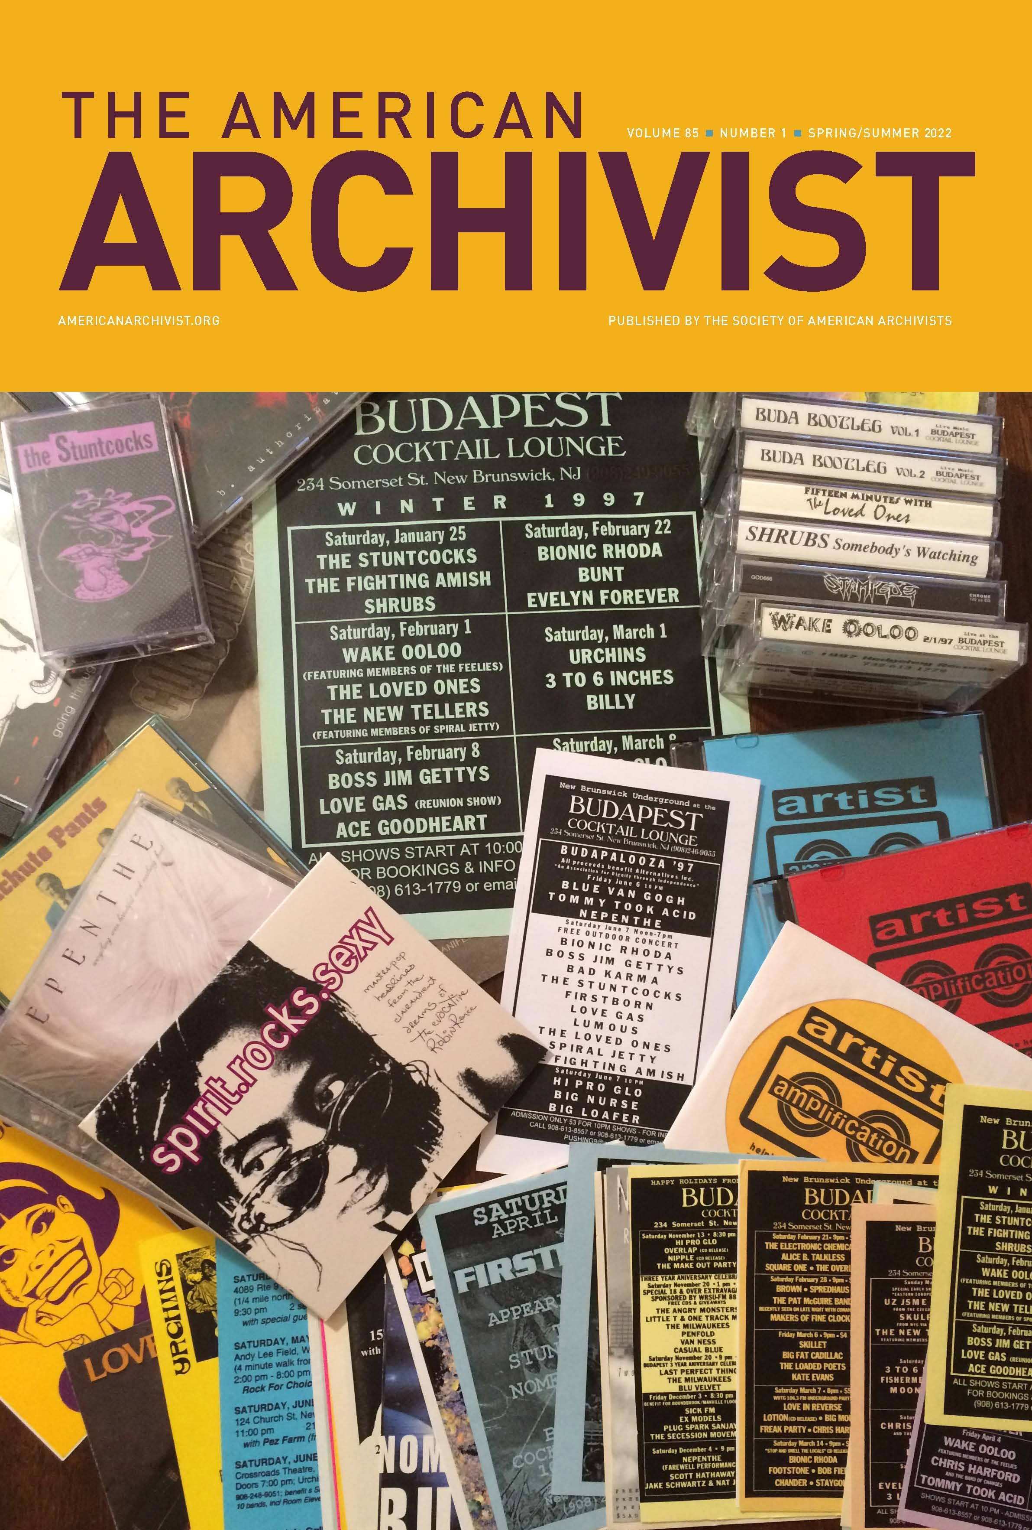
- New Issue of American Archivist
Issue 85.1 (Spring/Summer 2023) was published in June and features the 2021 presidential address from Rachel Vagts, the 2021 Theodore Pease Award-winning article, 12 articles, and three book reviews. Check out the table of contents. Of the 31 contributors, 22 are first-time contributors to the journal.
- Special Section on Middle Eastern and North African Archives
At its July meeting, the American Archivist Editorial Board approved a proposal for a special section on Middle East and North African archives, slated for issue 86.2 (Fall/Winter 2023). Board members Sumayya Ahmed and Rebecca Hankins will serve as guest editors. The
call for submissions has been published and submissions are due February 2023.

- A*CENSUS Distribution Conversations
American Archivist Editor Amy Cooper Cary, the A*CENSUS Distribution committee member Erin Stoddart, and Abigail have been planning publication and distribution of A*CENSUS content in American Archivist. The initial survey data and reports will be published in a branded section in 86.1 (Spring/Summer 2023). Issues 86.2 (Fall/Winter 2023) and 87.1 (Spring/Summer 2024) will continue to feature analysis of the data by invited contributors. Issue 87.2 (Fall/Winter 2024) will feature articles received from an open call for archivists to engage with the data.

- New Content on Reviews Portal
The Reviews Editors Rose Buchanan and Stephanie Luke have been actively publishing new content in unique formats on the Reviews Portal (12 new reviews in 2022!) and cross-promoting portal content in the Spring/Summer 2022 issue. Buchanan and Luke are also developing a series of reviews that engage with influential articles by archivist and SAA Fellow John Fleckner. This series of 10-12 “intergenerational conversations” will be published on the portal throughout the year and include an introduction to Fleckner’s work written by Fleckner and Rand Jimerson.
III. ARCHIVAL OUTLOOK
As part of pursuing DEIA content according to SAA’s Strategic Plan, featured articles in the May/June and July/August issues include:
- “A Legacy of Life, Love, and Hope in Special Collections: The Papers of LGBTQ+ Anthropologist Stephen O. Murray,” by Leslie M. Van Veen McRoberts
- “Bringing Artist Archives into Focus: Making Accessible the Greer Lankton Collection,” by Sinead Bligh
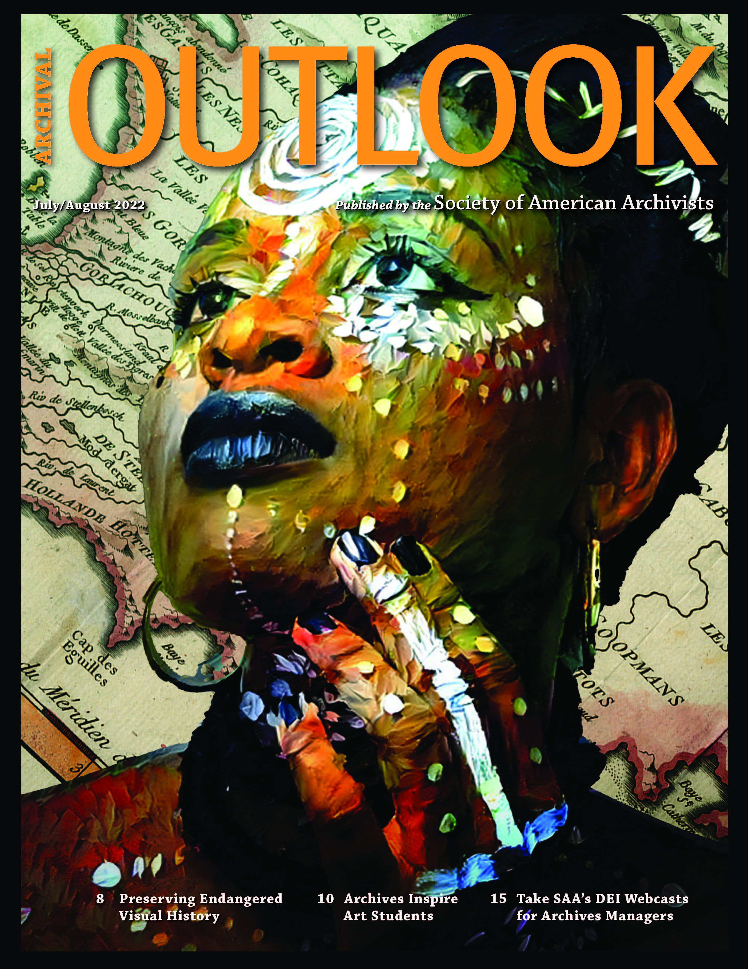
- “‘The Bridges That Carried Us Over’: Documenting Black History in California’s Inland Empire” by Eric Milenkiewicz
- “Expanding the Reach of the Cosmic Dancer: Inter-Campus Collaboration Provides Access to the Works of Rev. Dr. Mitsuo Aoki,” by Helen Wong Smith and Janel Quirante
- “Archives Inspire: Creating Primary Source Instruction for Art Students at University of Texas at Arlington” by Evan Spencer (from which the cover art to the right comes from)
Nearly all of these authors are publishing for the first time with SAA.
IV. DICTIONARY OF ARCHIVES TERMINOLOGY
The Dictionary of Archives Terminology continues to be updated to reflect improvements to definitions based on user feedback as well as introduce new terminology. The nine-member working group meets every Wednesday via Zoom to define terminology and draft the Word of the Week. New social media posts on SAA’s Instagram has also increased engagement with Word of the Week and SAA’s account, accruing 450 new followers since May.
V. OUTREACH & PROMOTION
A. Virtual Event Planning
- May 19: SAA Publications and American Archivist Peer Review Forum
This free virtual forum, led by SAA Publications Editor Stacie Williams and American Archivist Editor Amy Cooper Cary, discussed the critical nature and important elements of a peer review, provided an overview of SAA’s peer review process, and answered participants’ questions on how they could get involved. Sponsored by the SAA Publications Board and American Archivist Editorial Board, about 100 people attended the event; and about 40 people signed up to be peer reviewers for American Archivist and SAA publications.
- One Book, One Profession Panel Discussion Fall 2022 (date TBD)
Cheryl Oestreicher’s Waldo Gifford Leland Award-winning book Reference and Access for Archives and Manuscripts (Vol. 4, Archival Fundamentals Series III, SAA, 2020) is the 2022 selection for this reading initiative. The book is particularly relevant as archivists consider issues of access during different stages of the COVID-19 pandemic, and the book explores barriers for various users and ways to remove them. Sponsored by the SAA Publications Board.
- Write Away Forum on SAA Publication Opportunities Fall 2022 (date TBD)
This annual open forum will highlight various publishing outlets and answer queries on what and how to submit content, topic trends and new directions, and how to connect with editors after the webinar. Panelists include Publications Editor Stacie Williams, American Archivist Editor Amy Cooper Cary, American Archivist Reviews Editors Rose Buchanan and Stephanie Luke, Archival Futures Series Co-editor Bethany Anderson, Archival Outlook Editor Abigail Christian, and Dictionary Working Group Chair Rosemary Pleva Flynn.
- Archives in Context Podcast
Season 6 of the podcast has wrapped with an episode featuring the work and expansion of the SAA Foundation. New this season is that all episodes include a transcript to increase accessibility. This will be part of the workflow moving forward, and past episodes will be updated with transcripts as well. The team is planning for Season 7, which will begin fall 2022. The new American Archivist Reviews Editors Rose Buchanan and Stephanie Luke have succeeded Bethany Anderson, one of the podcast’s cofounders, as team producers.

- Reviews of SAA Books in the Professional Literature
  - Advancing Preservation of Archives and Manuscripts (SAA, 2020)
    - Journal of Western Archives Vol 13,
    - Journal of Australian Library and Information Association 71.1, and
    - American Archivist 84.2
  - “All Shook Up”: The Legacy of Terry Cook (SAA, 2020)
    - Journal of Western Archives Vol 13
  - Archival Accessioning (SAA, 2021)
    - Journal of Western Archives Vol 13
  - Archival Virtue: Relationship, Obligation, and the Just Archives (SAA, 2021)
    - Journal of Western Archives Vol 13 and
    - American Archivist 85.1
  - Defining a Discipline: Archival Research and Practice in the 21st Century (SAA, 2020)
    - Journal of Australian Library and Information Association 70.4

- Book Sales
- A book sale during the month of July offered 15% off five titles on the theme of “growing archival relationships.” A total of 63 books were sold and generated a gross revenue of $1,969.
- The Annual Meeting book sale continues as an online book sale through August 31. This year 23 titles are part of the conference promotion, discounted at 10% to 50% off. These titles were selected based on existing inventory, sales trends, and publication date. The online bookstore has a special tab—Conference Book Sale—that link to the titles on sale, and a series of emails also promote the sale.
VI. Marketing & Communications
- ARCHIVES*RECORDS 2022 Promotion
Drafted email communications around registration, hotels, and the conference schedule for the Annual Meeting in June through August; coordinated design of conference logo; served as a staff liaison for the 2022 Host Committee; promoted sponsorship and booth sales through email and social media; and contracted on-site photographer.

- Press Releases, Email Campaign, and Social Media for 25 Awards Recipients & Fellows
Drafted and distributed press releases for each awards recipient and new SAA Fellow. Coordinated artwork for awards certificates and plaques, and wrote script for recognition at the Annual Meeting.

- SAA Content Calendar
Coordinated ongoing content calendar for email campaigns and social media for association-wide news, including revitalizing SAA Education Newsletter.

- SAA Statements
Copyedited and promoted communications for “Calls for Further Consideration of Policy Changes for Operation of George W. Bush Presidential Library”

- SAA Foundation Fundraiser
Created graphics and messaging for fundraising campaign and distribution via email and social media. Fundraiser raised $5,420 for the Strategic Growth Fund.

