Agenda VI.D.4.

Society of American Archivists
Council Meeting
May 15-17, 2023
Chicago, IL

Staff Report: Publications Program Overview
February 2023–May 2023
(Prepared by Abigail Christian)

I. QUARTER HIGHLIGHTS
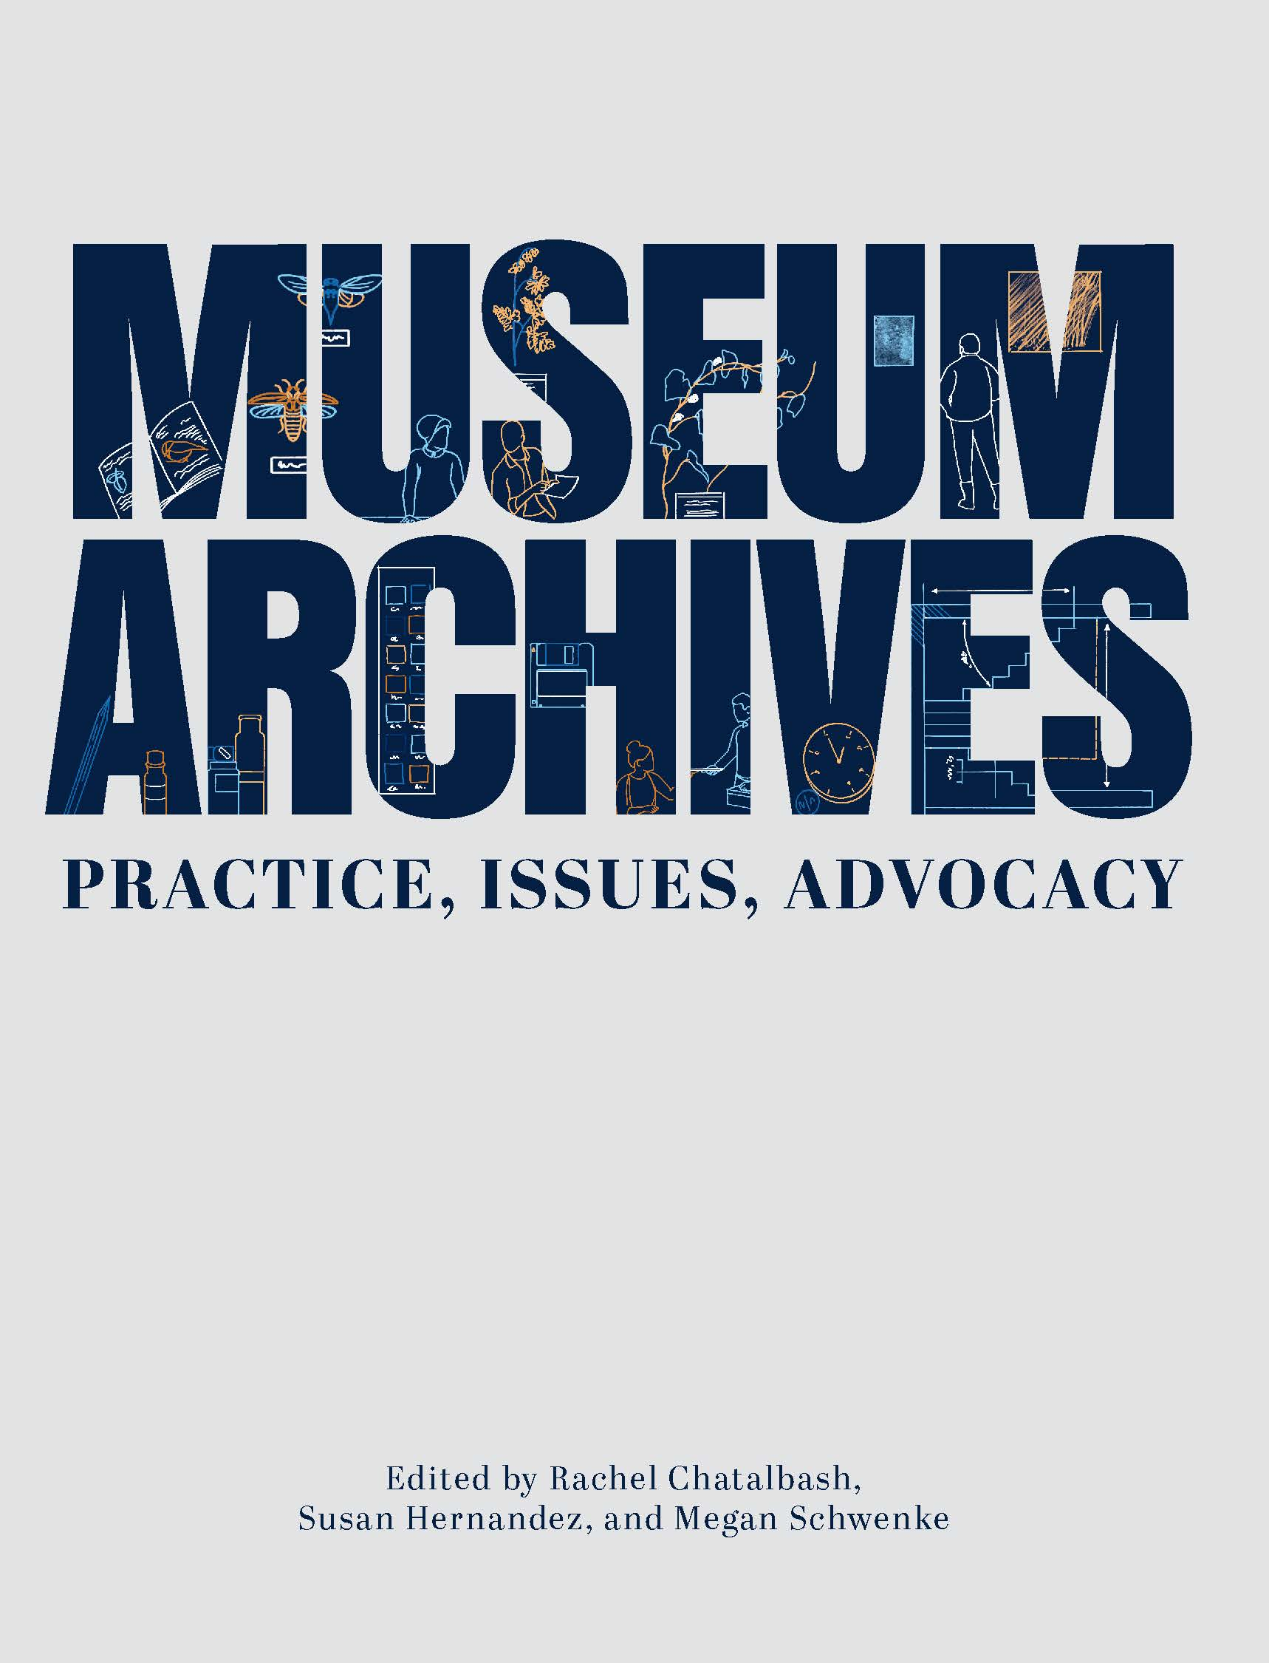
- We are celebrating and actively promoting new books Museum Archives: Practice, Issues, Advocacy, edited by Rachel Chatalbash, Susan Hernandez, and Megan Schwenke (which is being translated into Japanese), and Born-Digital Design Records, edited by Samantha Winn and part of the Trends in Archives Practice Series.
- The American Archivist Readership survey in March asked members about their reading experience of the digital-only journal and how it can be improved.
- We’ve held several sales, one partnering with the ACA exam participants, and advertised our books at a number of regional spring conferences.
- The Publications team has taken on or assisted this year with the SAA Election, Section meetings during the conference, Section elections, and SAA Awards.
II. BOOKS
- Publications Board
- The Publications Board met virtually on April 14 to discuss new proposals and plan One Book, One Profession events. The Board’s next meeting is in July.

- Project Updates
- In Production
  - Archival Futures Series (SAA/ALA): Decolonial Archival Futures by Krista McCracken and Skylee-Storm Hogan.
  - Teaching Primary Source Research Skills to 21st-Century Learners by Julie Thomas.

- Manuscripts in Process
- Alone in the Stacks: Succeeding in a Small Repository by Christina Zamon.
- 410 Measurable Learning Outcomes for Primary Source Literacy by Robin Katz.
3. Archival Fundamentals Series III, Volume 6: Selecting and Appraising Archives and Manuscripts by Margery Sly.
4. Archival Fundamentals Series III, Volume 7: Introducing Archives and Manuscripts by Peter J. Wosh and Michael J. Kurtz.
5. Lifting As They Climbed: How Archivists of Color Changed the Landscape of SAA edited by Steven Booth and Barrye Brown.
6. Remedy, Rectify, and Reconstruct: Case Studies in Inclusive and Reparative Archival Description Efforts, edited by Katherine M. Wisser and Elena C. Hinkle
7. Radical Visions: New Perspectives in Special Collections Curatorship, edited by Jillian Cuellar and Agnieszka Czeblakow.
8. Archival Futures Series (SAA/ALA): Archives, Time Travel, and Pop Culture by Lynne M. Thomas and Katy Rawdon.
9. Archival and Special Collections Facilities: Guidelines for Archivists, Librarians, Architects, and Engineers, Revised Edition, by Michele Pacifico.
II. American Archivist
- New Issue of American Archivist
Issue 86.1 (Spring/Summer 2023) is forthcoming in June and features 4 articles, the A*CENSUS II All Archivists Survey report, the 2022 presidential address, and 5 book reviews. The call for content engaging with the A*CENSUS II surveys will be published in Archival Outlook and on SAA’s website this summer.
- Special Section on Middle Eastern and North African Archives
Board members Sumayya Ahmed and Rebecca Hankins are serving as guest editors for a special section on Middle Eastern and North African archives, slated for issue 86.2 (Fall/Winter 2023).
- Readership Survey
The Board conducted a readerships survey in March, which was open for three weeks and garnered 212 responses. The brief survey sought to understand how readers interact with the all-digital journal and the reading experience and content can be improved. Look for a summary of the results in the July/August issue of Archival Outlook.

- Editorial Board
  - American Archivist Editor Amy Cooper Cary was reappointed by the Council for another term to serve from January 2024 to December 2026.
  - The Board met virtually on March 31 to discuss the results of the Readership Survey and consider how we can expand our marketing efforts to engage readers year-round rather than just when new issues are published. The Board’s next meeting is in June.

E. New Content on Reviews Portal
The Reviews Editors Rose Buchanan and Stephanie Luke have developed a new series of reviews that engage with influential articles by archivist and SAA Fellow John Fleckner. This series of 10-12 “intergenerational conversations” will be published on the portal throughout 2023. Check them out here.

III. ARCHIVAL OUTLOOK
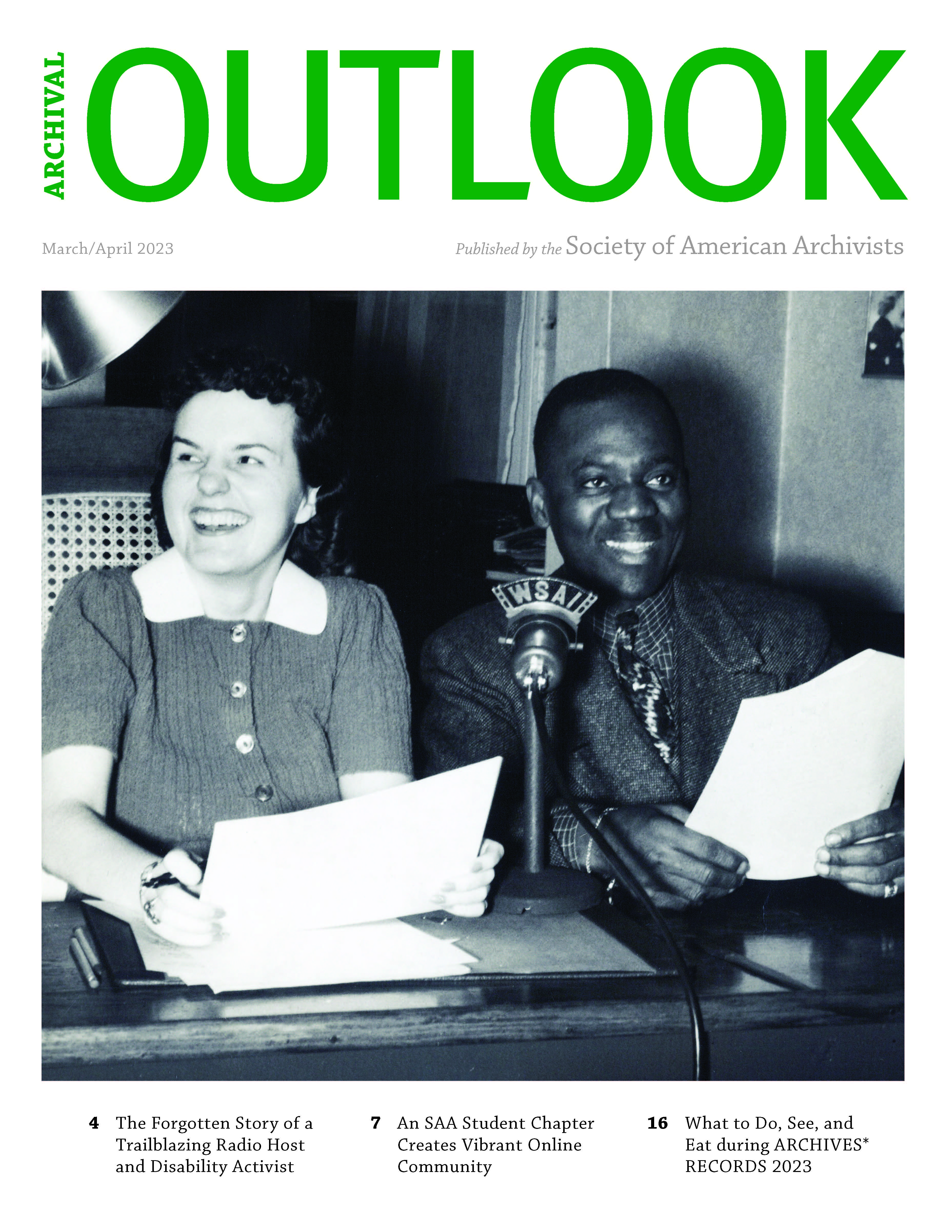
As part of pursuing DEIA content according to SAA’s Strategic Plan, featured articles in the January/February and March/April issues include:
- “Finding Hidden Voices in Medical Archives” by Brian D. Fors and Judith Arendall.
- “Best Practices for Collection, Confidentiality, and Privacy of Student Oral Histories” by Kelly Bartlett.
- “The Forgotten Voice of Kay Irion: A 1940s Pioneering Disability Activist and Radio Show Host” by Arabeth Balesko.
- Centering Community Archives: BIPOC and Queer Solidarity in Community-Driven Archives” by Kenia Menchaca Lozano, Jessica Salow, Alexander Soto, and Vanessa Jasmine Torrez
IV. DICTIONARY OF ARCHIVES TERMINOLOGY
The Dictionary of Archives Terminology continues to be updated to reflect improvements to definitions based on user feedback as well as introduce new terminology. The nine-member working group meets every Wednesday via Zoom to define terminology and draft the Word of the Week. Upcoming this year is a platform migration project for the dictionary’s software, initiated by the vendor.

V. OUTREACH & PROMOTION
A. Virtual Event: One Book, One Profession Panel Discussion May 23
Cheryl Oestreicher’s Waldo Gifford Leland Award-winning book Reference and Access for Archives and Manuscripts (Vol. 4, Archival Fundamentals Series III, SAA, 2020) is the 2022-2023 selection for this reading initiative. The book is particularly relevant as archivists consider issues of access during different stages of the COVID-19 pandemic, and the book explores barriers for various users and ways to remove them. Sponsored by the SAA Publications Board.

- Archives in Context Podcast
Season 7 launched in December. Episode 1 features conversations with attendees at ARCHIVES*RECORDS 2022. Episode 2 features an interview with SAA author Cheryl Oestreicher. Episode 3 talks with Marika Cifor about Episode 4 (forthcoming) talks with contributors to SAA’s recent book Born-Digital Design Records.
C. Reviews of SAA Books in the Professional Literature
  - Archival Accessioning (SAA, 2021)
    - Journal of Contemporary Archival Studies Vol 10
  - Archival Virtue: Relationship, Obligation, and the Just Archives (SAA, 2021)
    - Journal of Contemporary Archival Studies Vol 10
  - Making Your Tools Work for You (SAA, 2020)
    - Journal of Contemporary Archival Studies Vol 10
    - Journal of Western Archives
- Praise for Archival Accessioning
Haley E. Aaron (Alabama Department of Archives and History) reviews Archival Accessioning, edited by Audra Eagle Yun (SAA, 2021), in Archival Issues. She writes, "The theory and practice of archival accessioning remains largely overlooked in professional literature. Archival Accessioning seeks to address this gap through a robust introduction to the history and principles of accessioning and a collection of thoughtful case studies."

- Praise for Making Your Tools Work for You
Rachel I. Howard (University of Louisville Archives and Special Collections) reviews Marking Your Tools Work for You by Max Eckard (SAA, 2020) in Archival Issues. She writes, " [Making Your Tools Work for You] will continue to serve as a resource at my place of work, and I would recommend it to archivists attempting to use technology more effectively and technologists seeking to better serve archivists.”
- Praise for Managing Business Archives
Digital archivist Amanda Garfunkel reviews Managing Business Archives (SAA, 2022) edited by Sarah Polirer in Mid-Atlantic Archivist. She writes, "As someone who previously worked with business archives…[the book] would have been a good resource to have as I transitioned out of library school and an academic environment to the realities of how 'best practices' aren't always attainable or feasible in a business setting."
- Praise for Managing Business Archives
Erin M. Louthen (Diocese of San Jose) reviews Managing Business Archives (SAA, 2022), edited by Sarah Polirer, in the Journal of Western Archives. She writes, "Both the editor and its expert contributors have created a book that has the potential of becoming a modern classic in the world of information professionals. Placing an emphasis on practicality and real-world situations that will be useful to archivists in any field, business or otherwise, the book offers an incredibly resourceful and comprehensive look at the ways a wide variety of business and organizational archivists tackle both day-to-day issues and long-term (or legacy) problems with creative, pragmatic strategies and solutions."
- Read the full review and get your copy from the SAA Bookstore today!
- Print | Epub | PDF | Kindle
- List $69.00 | SAA members $49.00
- Praise for Born-Digital Design Records
Nicole Grady Mountjoy (University of the Pacific) reviews Born-Digital Design Records(SAA, 2022), edited by Samantha Winn, in Journal of Western Archives. She writes, "The technical terminology can seem intimidating, especially to those new to the field, but the authors do a good job in breaking the explanations and examples down into easily digestible parts. I would recommend this title to archivists without any experience with born-digital design records, especially if you will be working with those records in the future.”
Read the full review and get your copy today from the SAA Bookstore!
- Print | Epub | PDF | Kindle
List $39 | SAA Member $29
- Praise for Museum Archives
Laura J. French (Baylor University) reviews Museum Archives: Practice, Issues, Advocacy, edited by Rachel Chatalbash, Susan Hernandez, and Megan Schwenke (SAA, 2022), in Journal of Western Archives. She writes, "It is highly gratifying to read a volume which places such an emphasis on advocacy by archivists for archives. Additionally, the authors understand and clearly articulate that the best form of advocacy is to demonstrate a high degree of proficiency in the core functions of their responsibilities.”
Read the full review and get your copy today from the SAA Bookstore!
- Print | Epub | PDF | Kindle
List $69 | SAA Member $49

D. Book Sales & Promos
- February: our “For Love of a Book” sale offered a 20% discount on our Trends in Archives Practice series, during which we sold 77 books.
- March: we partnered with the Academy of Certified Archivists to select titles on their “to-read” list for their examination which takes place in May. These books were 20% to 60% off, and we sold 111 or $4,221.18.
- April: we promoted three recent thought-leadership books about the profession: Defining a Discipline, Archival Values, and Archival Virtue
- In each issue of the Education newsletter, we are promoting one book that’s related to one of the courses being offered.
- We placed an ad for Creating Family Archives in the National Genealogical Society’s conference program.
- SAA donated books as prizes for the Midwest Archives Conference, Society of Ohio Archivists, and the Society of Southwest Archivists.
- Permission has been granted to SAA member Yayoi Tsutsui to translate Museum Archives (2022) into Japanese.
VI. SAA Marketing & Communications

- SAA-wide Content and Content Calendar
Coordinated ongoing content calendar for email campaigns and social media for association-wide news.

- Annual Meeting Marketing
Developing graphic assets, booking photographer and videographer, and building and improving on SAA’s email campaigns. See page 6 for analysis of past Annual Meeting campaigns that are informing this year’s decisions.
VII. SAA governance activities
- 2023 Awards Cycle
Drafted press releases for 22+ awards recipients and assisted with communications to subcommittees email and web communications for promotion of 2023 awards cycle.

- 2023 Election Cycle
Developed ballot and launched 2023 election cycle in the absence of a governance manager. Confirmed elected leaders.

- Component Group Annual Meetings
Scheduled and set up all section, board, and committee virtual meetings in June and July, leading up to the Annual Meeting.

- Section Elections
In-progress: conducting election cycle for all SAA sections.

- Staff Liaisons
Served as staff liaisons for the Standards Committee; 2023 Host Committee; Crisis, Disaster, Tragedy and Response Working Group; and the Committee on Public Awareness.

Analysis of Annual Meeting Email Campaign Statistics – 2021 and 2022
(Prepared by Julia Pillard)

Below are statistics on the open rates for Annual Meeting promotional emails. These emails were specifically encouraging people to register for the meeting (vs. other emails on the conference book sale, awards, etc.). Included is a graph comparing open rates and click rates for the two years.

In both years, we sent 11 promotional emails starting in May and ending in August. Our email list for the Annual Meeting has stayed comparatively stable: we had an average of 28,428 recipients in 2021 and an average of 28,318 recipients in 2022. The list is segmented from there—the nonmember list in 2022, for example, was 21,799.

Our open rate average increased from 18.6% (5,309) in 2021 to 29.5% (8,387) in 2022. Our click rate average stayed roughly the same: 1.57% (450) compared to 2022's 1.5% (413). Engagement decreased as the annual meeting neared, suggesting that interest tapers off as the feasibility of attending diminishes.

One data point here needs extra explanation; the second email we sent in 2022 was sent exclusively to a non-members segment. This accounts for the dip you see early on in open rates—it was sent to fewer people and was opened by fewer as a result. The percentage opened, however, stayed consistent: 26.1%.

In 2022, there was a concerted effort to decrease the amount of text that each email contained, focusing on the main points and driving people towards CTAs. This seems to have improved our open rates and had a negligible impact on our click-through rates. New marketing proposals for 2023 (increased use of segmentation, more focused CTAs) will be implemented and measured to see what impact they have on click rates and open rates.

