Society of American Archivists
Council Meeting
February 17-19, 2026
Hybrid, Chicago, IL

Staff Report: Publications Program Overview
October–December 2025
(Prepared by Julie Chyna, Hannah Stryker, Julia Pillard, and Rana Salzmann)

I. QUARTER HIGHLIGHTS
- American Archivist 88.2 was published.
- Julie Chyna was hired as SAA Assistant Director of Publications.
II. BOOKS
Publications Board
The Publications Board met in December 2025. The Board is working on scheduling their next meeting. Candidates for the Publications Editor are being considered for a new editor’s term to begin in early 2026. The new editor will overlap with the current editor for a three- to six-month period of onboarding.

- Project Updates
- In Production
  - Selecting and Appraising Archives and Manuscripts (AFS III), edited by Audra Yun and Chela Weber, is currently in the last stages of design, planned for priority publication in spring 2026.
  - Radical Visions: New Perspectives in Special Collections Curatorship, edited by Jillian Cuellar and Agnieszka Czeblakow, is currently in the design process.
  - Expanding the Record: Case Studies in Reparative Description, edited by Katherine M. Wisser and Elena C. Hinkle, is in the final copyediting stages along with the preliminary design stages.
  - Managing Digital Congressional Collections: A Technical Supplement to Managing Congressional Collections, edited by Carly Dearborn, Robert Lay, and Hope Bibens is a digital supplement that was submitted to production in Summer 2025 and is currently in copyediting.
  - See You at The Meeting: How Archivists of Color Changed the Landscape of SAA edited by Steven Booth and Barrye Brown. The manuscript has been received and is in the early stages of copyediting.
  - 610 Measurable Learning Outcomes for Primary Source Literacy by Robin Katz. The manuscript was received in August 2025 and is currently in copyediting.

- In Process
  - Archival Futures Series (SAA/ALA): Archives, Time Travel, and Pop Culture by Lynne M. Thomas and Katy Rawdon.
  - Accessibility in the Archives, edited by Michelle Ganz, Chris Tanguay, and Ann Abney.

III. American Archivist

- American Archivist production
Issue 88.2 (Fall/Winter 2025) was published in December 2025. It features 7 articles and 7 reviews.

- Editorial Board
The Board had to cancel their December meeting due to extraneous circumstances. The Board is working on scheduling its make-up meeting.
C. New Content on Reviews Portal
Two reviews were published on the Portal during this quarter. A Discussion Group Guide was also published.

- Historical Communities: Cities, Erudition, and National Identity in Early Modern France
By Alexandra Zukas

- Published by the Author: Self-Publication in Nineteenth-Century African American Literature
By Lily Hunter, Reference and Instruction Librarian, Lincoln University

- Discussion Group Guide: American Archivist Special Section on Accessioning
By Rose Buchanan and Stephanie Luke, Reviews Co-Editors

Check out the latest posts here.

IV. ARCHIVAL OUTLOOK
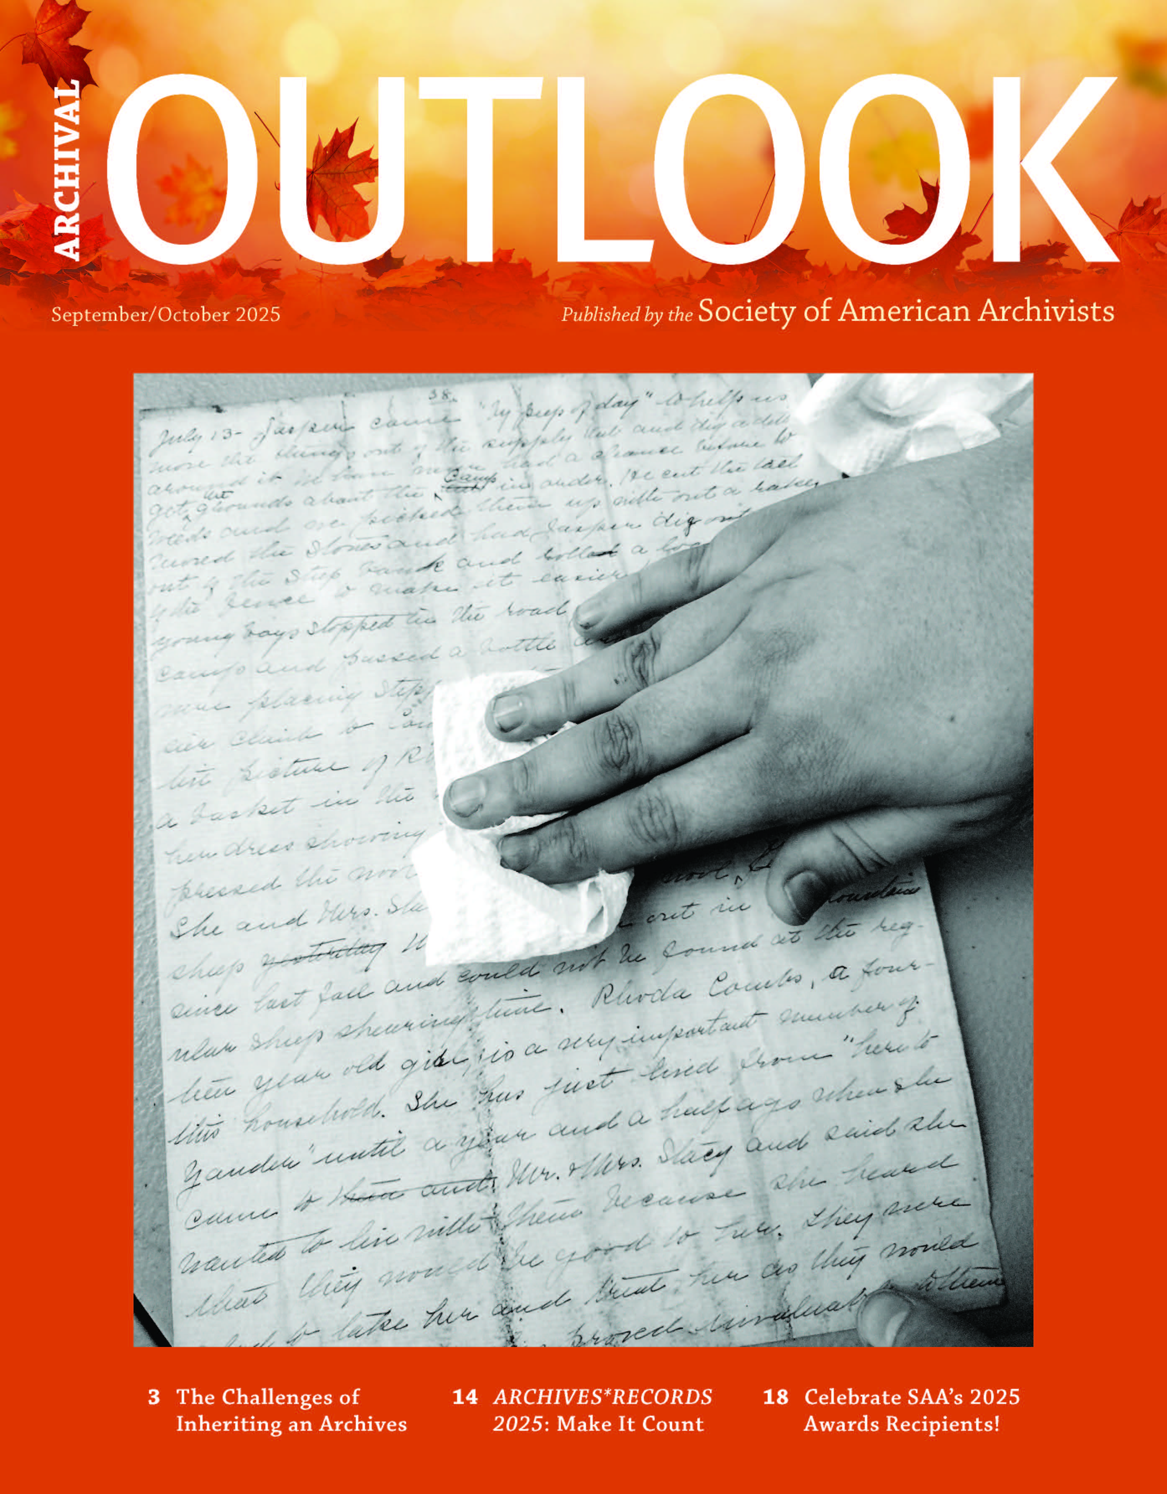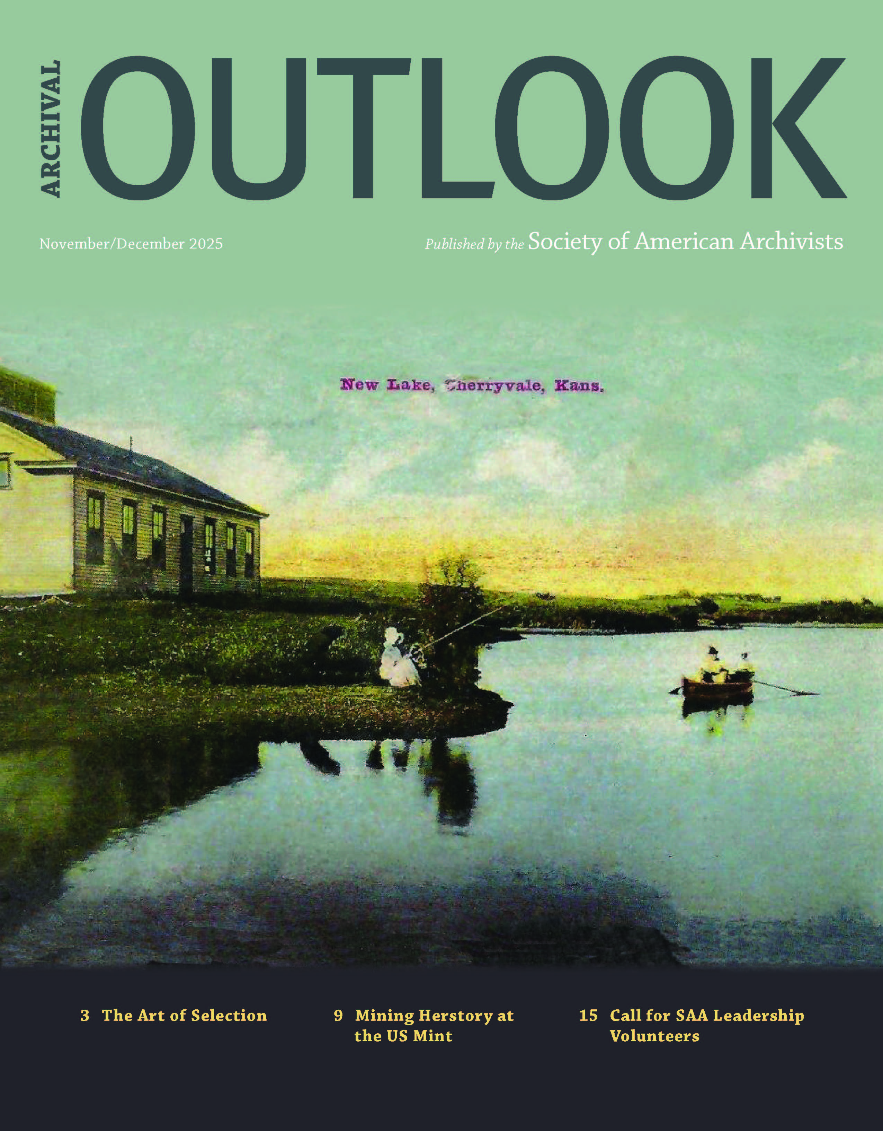
This quarter, the September/October and November/December issues were published and are available on the SAA website. (https://www2.archivists.org/archival-outlook/archival-outlook-back-issues-by-year)
V. DICTIONARY OF ARCHIVES TERMINOLOGY
- The Dictionary of Archives Terminology continues to be updated to reflect improvements to definitions based on user feedback as well as introduce new terminology. The nine-member working group meets every Wednesday via Zoom to define terminology and draft the Word of the Week.
- Platform training is ongoing post-migration.

VI. OUTREACH & PROMOTION
A. Reviews of SAA Books in the Professional Literature
- External promotion
  - New issues of AO and AA are shared with MARAC, ACA, and RBMS for promotion. In turn, SAA works to promote the publications of our sister organizations.
SAA Marketing & Communications
- Statements and News Items Highlights
  - Ballot Set for the 2026 SAA Election
  - SAA Council Convenes Special Meeting to Advance Key Governance and Planning Initiatives
  - SAA Foundation Board of Directors Advance Strategic Initiatives at the November Meeting
  - Upcoming Changes to the SAA Annual Meeting
- Marketing
  - The end of the year saw SAA wrapping up several initiatives related to membership and the Annual Meeting. A few new initiatives have begun and are being publicized by SAA
    - The SAA Call for Program Proposals closed in December with 190 submitted education sessions and professional posters.
    - The Call for Leaders closed in January after an extension, providing members with more time to submit nominations.
    - At the beginning of February, SAA released the call for the Storytelling Workshop Master Class. This event, taking place at the end of the month, is sponsored by COPA and is the first part of the “Finding Aid to My Soul” event.
  - Individual education courses were marketed via social media, as were individual articles from recent issues of Archival Outlook.
  - For Education, SAA has also begun using targeted regional emails to reach archivists who live close to in-person courses who might be interested in attending. A targeted campaign for an upcoming course in Oregon will be going out later this month.
  - SAA continues to utilize A/B testing and other analytics to review message reach and evaluate more and better ways to reach archivists across the country. With the addition of new staff member Matthew Novotny, our membership campaign is being reviewed and refined.
- Communications Procedures Reminder
  - SAA produces a large amount of content each month, from procedural updates to statements to professional information. Given those constraints, we ask the following when a statement is planned to be released:
    - Please ensure the statement is finalized prior to being shared with staff for release. Information, structure, and sentence-level changes should be finalized.
    - Staff will review the statement for clarity. Minor grammatical errors (correcting capitalization, commas, etc.) will be made by staff. Anything that requires larger clarification will be run past the body releasing the statement prior to the statement being released.
  - The goal of these guidelines is to minimize confusion and duplication of work and streamline the publication process.
  - Please reach out to Communications Manager Julia Pillard at jpillard@archivists.org if you have any questions.

