Jump In 3: Boston College Final Report
Adrienne Pruitt, Processing Archivist
May 1, 2015

Background
The Archives at John J. Burns Library, Boston College, holds over 12,000 linear feet of university archives records and manuscript collections. Born-digital materials had been trickling in for a few years, but the archives had no formal procedures for dealing with digital accessions. Legacy information migrated into Archivists’ Toolkit (implemented in 2011) did not consistently record the presence of digital media. A growing interest on the part of donors in transferring electronic records prompted further discussion, as did the retirement of a cohort of university professors and administrators who were used to doing their daily work electronically and whose papers included boxes and boxes of floppy disks and cds. As the trickle of born-digital materials increased to a medium-sized stream, a Digital Archives Group was created to come up with policies and procedures relating to these materials.

Process and findings
The Jump In 3 Initiative seemed like a good opportunity to address our digital media accessioning practices. While form and genre terms for digital media have been applied to accessions in Archivists’ Toolkit since 2013, no detailed inventory of born-digital media in our collections exists. Because there is limited staffing and many other claims on existing staff time, I chose to survey just one collection as proof of concept and a model for future work. The collection was a new accession that I knew would contain a fair amount of digital media.

The Edward J. Kilmartin, SJ, papers consist of the theology professor’s personal and professional papers. The bulk of the papers related to his numerous publications and consisted of notes, drafts, and final copies of his articles and books, many of them on 3.5” and 5.25” floppy disks. There was one loosely-filled record carton of disks.

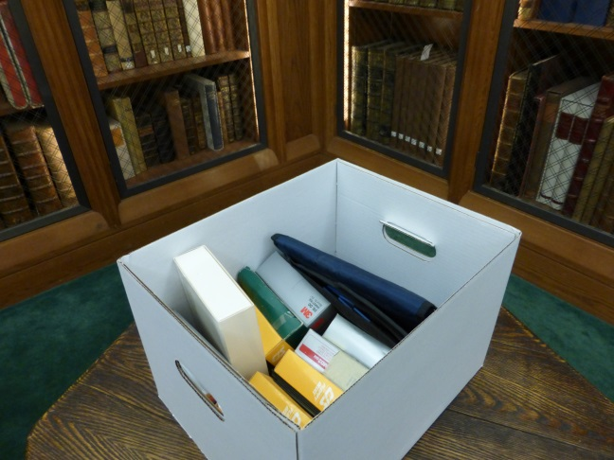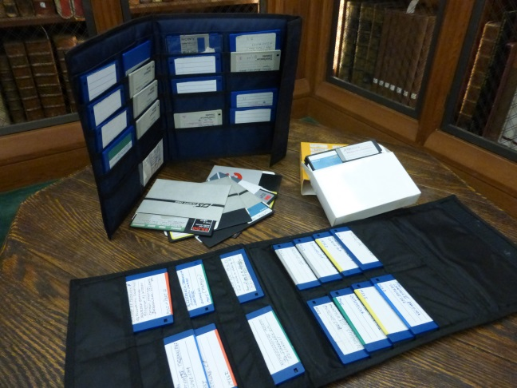

Materials in the collection surveyed

The survey process, while tedious, was brief. I read previous Jump In reports to help me think through what information we would most want to collect and design the inventory spreadsheet. Actually recording the information, for what turned out to be just 158 disks, took less than 4 hours. There were 112 5.25” disks and 46 3.5” disks, and almost all had some sort of identifying metadata. Disks were mostly formatted for PC but there were a few labeled as Mac disks. The majority of the materials were labeled as his writings and class notes. But I was surprised that a good quarter of them seem to be common word processing software. If they actually turn out to be software when the materials are further assessed at a digital forensics workstation, those disks will be deaccessioned, as will duplicate back-ups of Word documents.

Although this survey was necessarily modest, there were several unexpected and encouraging results. The survey did not take long to do, even taking into account item-level transcription of label information and media markings. The total potential storage capacity was under 200 MB, and a fair amount of the material seemed to be duplicative or not fit for permanent retention. As the archives is currently considering conducting larger-scale surveys of its holdings, this exercise was reassuring. Conducting a complete survey of all digital media seems extremely daunting given the lack of reliable legacy documentation, but it is definitely doable and could be folded into an overall collections assessment project without significantly increasing the amount of time it would take.

Next steps
A simplified template, based on the one used for the Jump In Initiative, has been added to our wiki documentation and will now be used for all accessions containing born-digital materials, linked as an external document to the accession record in Archivists’ Toolkit. A master digital media inventory that will include all accessions done from this point forward is being maintained on our shared drive. This survey instrument will also be useful as we plan larger-scale collection surveys in the future. All of this documentation will greatly benefit our ongoing efforts to manage born-digital records.

For this collection, the next step will be to use our new digital forensic workstation to further assess the records. Using a write blocker, files will be copied to our secure laptop, an inventory and checksums will be created, files checked for viruses, and deaccessioning decisions made. When it is clear how much time these further steps take, I will need to make decisions about exactly what work is appropriate at the accessioning or survey stages. For now, simply recording the presence of digital media in our collections reliably and accurately will be a good start!

