Introduction
UTSA Special Collections has no digital preservation system in place as of yet. Some electronic records have been stored on nightly backed-up servers administered by UTSA Libraries and UTSA’s Office of Information Technology, but the procedure for ingesting electronic records onto servers has been arbitrary, largely depending on the method of transfer (i.e. fully electronic, such as FTP, email, or hosting/downloading) or the removable media the records are stored on. More current removable media, such as CDs or DVDs, have been generally ingested as collections came in, depending on the amount of media. New accessions with a few CDs might be ingested as part of normal processing, while collections with larger numbers of CDs would be stored with the paper records, awaiting a time when the media could or needed to be ingested. Upon successful ingest, removable media would be returned to the rest of the collection as a type of back-up storage. Any media that could not be ingested due to obsolete carrier formats would be stored in archival folders with the rest of the collection. In the fall of 2013 Special Collections created a new position for a Digital Archivist, who was hired and tasked with implementing a new electronic records preservation system and ingest workflow, and we decided to participate in Jump In as a means of getting to know our electronic records better.

What we chose to survey & why
Upon pledging our participation in early 2014, our department was experiencing key changes. Our Head position was vacant, we were operating with recently reduced staff, and a new University Archivist had just joined the team after that position had been vacant the previous year. Additionally, our Digital Archivist was promoted to Head soon after we began this project. It was a time of flux, coupled with the time demands of our duty to serve patrons and run reading rooms in two separate locations. We were committed to getting a better understanding of our removable media situation, however, and we decided it would be an excellent way for our new University Archivist to get familiar with this aspect of these collections. So we made the decision to survey all University Archives (UA) collections within Special Collections, which represents about one quarter of our total physical holdings.

Who was involved
The Jump In physical survey was conducted by the University Archivist, Julianna Barrera-Gomez, but was supplemented by prior effort from Special Collections staff who recorded general information about the location of removable media in our collections database and on finding aids. Our Manuscripts Curator, Nikki Lynn Thomas, had previously taken part in a similar project that recorded information about electronic records on removable media based on keyword searches through the finding aids. This 2011 survey helped as a starting point for locating removable media in University Archives collections. Our new Head of Special Collections, Amy Rushing, oversaw the project and offered valuable advice, given her background with digital archives.

The survey process
After reviewing previous Jump In reports and thinking about what we wanted to record, Rushing put together a Google spreadsheet that we could use to do the inventory, with drop-down menus for controlled vocabulary. Barrera-Gomez added to the excel sheet Thomas had created by searching for keywords (e.g. disk, disc, floppy, electronic, CD, DVD, computer) through the finding aids to update the list. She also searched the descriptions of new accessions in our collections database for mentions of removable media.

We set up a laptop on a cart to be our mobile survey station in the stacks. We endeavored to take photos of the media types from each box that we found and created a grid sheet that we could use to capture the measurements of media and also record collection information in dry erase marker. The realities of an overwhelming number of media made individual photos of each disk impossible for this report, but we may consider using this method to record descriptive metadata present on most media in the future (Appendix, Figure 1).

We then completed the survey of all boxes identified as having removable media on our excel sheet. We also spot-checked through other UA collections likely to hold removable media, and looked extensively through unprocessed boxes. The physical inventory took approximately 3 business days to complete. Completing the survey matrix, however, took about a week as we had to search for maximum disk sizes per media type.

What we found
We found 5 different removable media types in our UA collections, including:

Summary of Removable Media Types | N=637
3.5” floppy disks | 388 (61%)
CDs | 171 (27%)
DVDs | 66 (10%)
5.25” floppy disks | 8 (1%)
Zip disks | 4 (1%)

For many of the media we found, we were not able to determine the maximum size because this information was not included or it was covered by printed labels or markings. We decided to estimate maximum size based on common size numbers listed on Wikipedia for each media type. We also decided to record disk sizes in megabytes (MB) to more easily capture sizes for smaller media types, such as 5.25” floppy disks (which contain up to 360KB or 0.351563MB). To convert digital storage sizes between kilobytes, megabytes, and gigabytes we used Google Unit Converter. See Appendix, Figures 5 & 6 for more information on disk findings and size calculations.

Challenges we faced & surprises
Originally, we had planned to survey all of our holdings for Jump In, but the department upheaval and our multiple storage locations made that an unattainable goal. We had also hoped to solicit help from our undergraduate student workers, but we were quite surprised to learn that they were completely unfamiliar with obsolete removable media, such as floppy disks. We looked for resources online to quickly educate our young student workers, but we found that information about removable media (such as maximum storage space, or common brands) was harder to find than we imagined. We relied on sources such as Wikipedia or Mediapedia, but sometimes this information was hard to sort through, or even conflicting. Rushing noted the need for a quick visual guide (like a field guide with images) to help train students and we have partnered with the SAA Manuscripts Repositories section to create a poster with relevant information to help train future survey participants.

We were also surprised by the amount of removable media in unprocessed University Archives collections. University records that had not been ingested were part of the general backlog, but (to our temporary relief) the majority of these are on CDs or DVDs and do not have the same risk for format obsolescence that older media have. Additionally, we took note of the dual nature of collecting sources in UA holdings—the institutional records vs. the papers of professors. Many of the institutional records are beginning to feature removable media on CD/DVDs as our transfers begin to catch up to records created and stored on this type of media 10-15 years ago, while prior accessions only rarely involved removable media. We anticipate that we will receive even more of these in the future. In contrast, the papers of Norma Cantu, a noted professor at UTSA, represent a new shift in personal records we will likely begin to see as professors deposit materials that span their entire career as researchers. Her collection alone represented 85% of our total number of disks, held 82% of the maximum size of all removable media, and had removable media formats spanning nearly every category we encountered. As can be seen in the Appendix, Figure 4, processing the electronic records of this collection will no doubt be challenging, as Cantu deposited many disks with very little documentation about the contents.

Lessons learned & next steps
Next steps include finishing the survey of manuscript collections, coming up with workflows for getting material off removable media, setting up a quarantine station, and setting up workflows for processing the born-digital material. These next steps will certainly play a role in forming a collection development policy for UA collections, and may also impact the manuscript collection development policy. We anticipate filling the vacant digital archivist position by mid-2014 and look forward to getting back on track with our digital preservation planning.

Appendix:

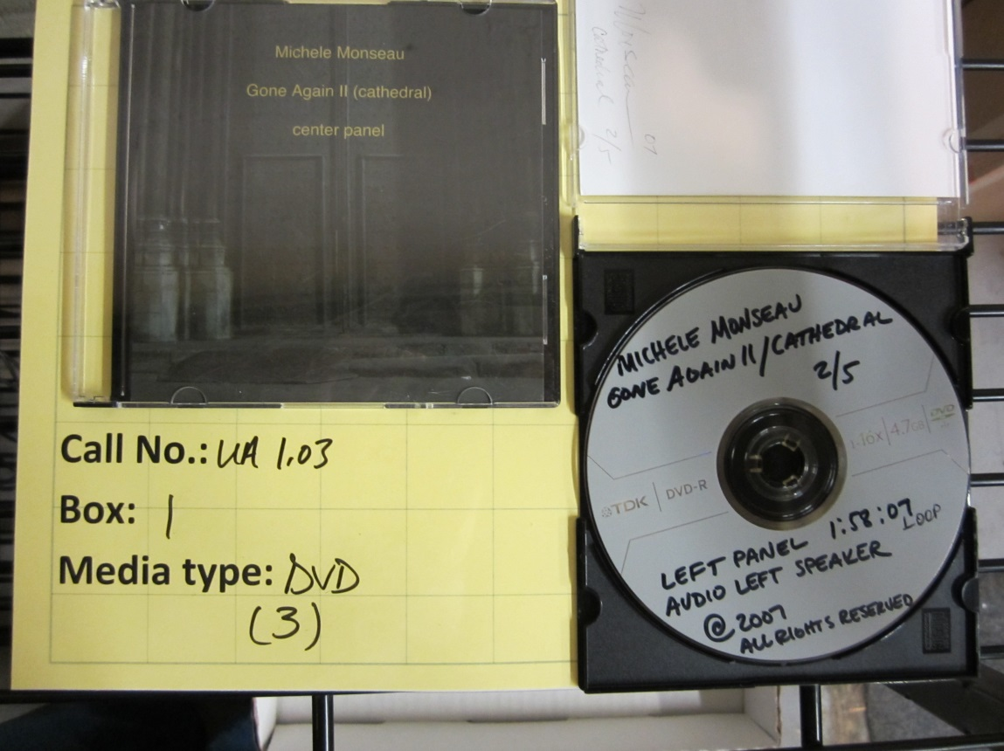
Figure 1: An example of a disc from a UTSA department that includes well-documented information.

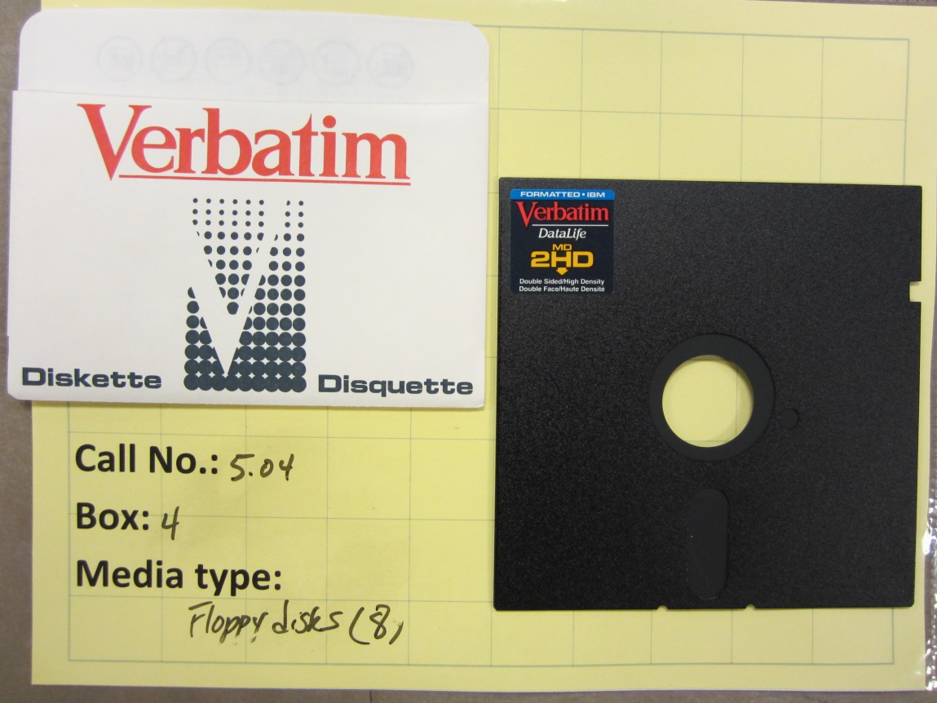
Figure 2: An example of our oldest removable media type, in this case without much descriptive metadata.
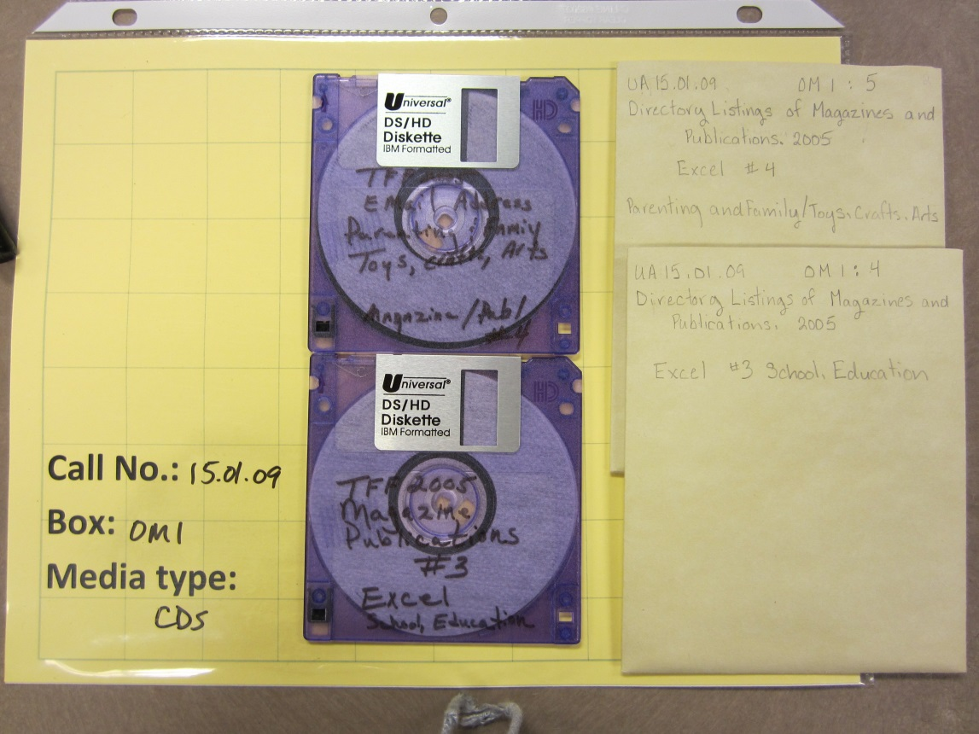
Figure 3: An example of removable media not yet ingested but stored in archival enclosures.

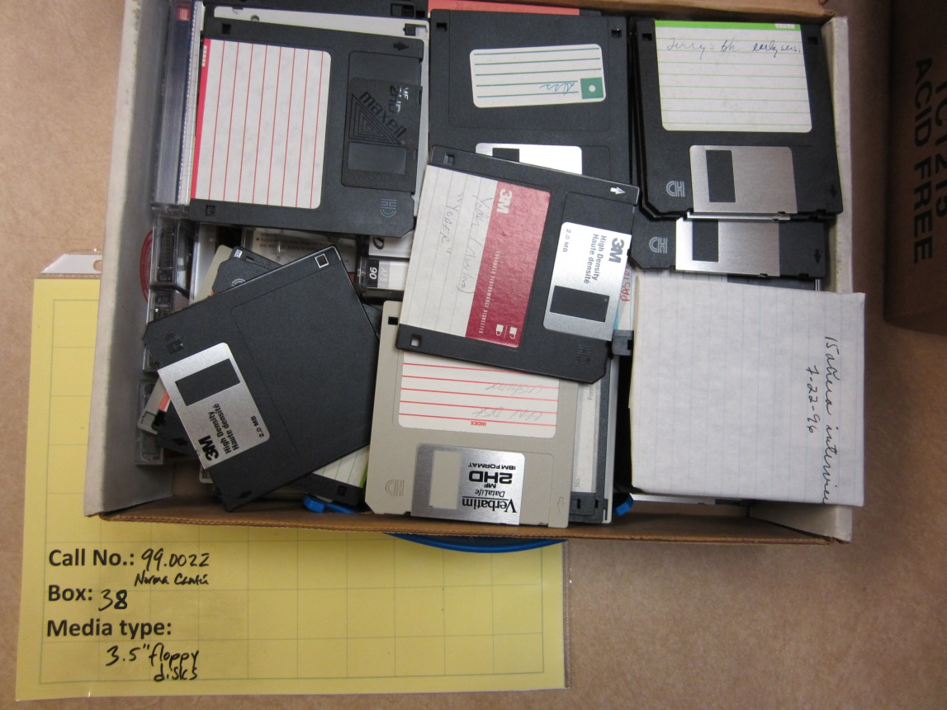
Figure 4: An example of floppy disks in an unprocessed collection of a UTSA professor’s papers.
This collection made up 85% of our total number of disks.

Figure 5: Percentage of removable media types in University Archives collections, total = 637.

Figure 6: Maximum potential size of all media, measured in megabytes (MB).

The UTSA Libraries Special Collections Jump In Inventory Team:

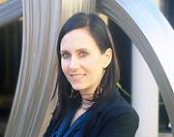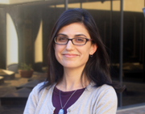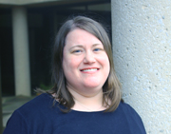
Amy Rushing, Julianna Barrera-Gomez, Nikki Lynn Thomas,
Head of Special Collections University Archivist Manuscripts Curator

