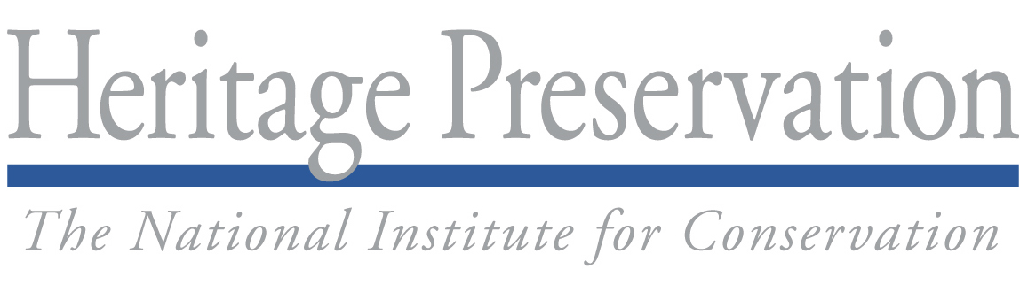
For Immediate Release Contact: Mary Rogers, 202-233-0800 or taskforce@heritagepreservation.org

What Will You Do for MayDay?
Cultural Institutions Prepare for Emergencies

WASHINGTON, DC—Libraries, museums, archives, and arts and historic preservation organizations across the nation will set aside May 1, 2009, to participate in MayDay, a national effort to prepare for disasters.
Sponsored by Heritage Preservation and other members of the Heritage Emergency National Task Force, MayDay encourages organizations to take one simple step to protect the art, artifacts, records, and historic sites they hold in trust.
Any organization can participate in MayDay. Last year, staff at the Tacoma Art Museum and the Museum of Glass in Tacoma, WA, met to share their collection emergency plans. Lycoming College’s library in Williamsport, PA, partnered with the college’s security department to organize a building tour for first responders. The Central New York Library Resources Council in Syracuse, NY, sponsored a discussion on health and safety issues for archives.
Heritage Preservation is collecting examples of creative but practical measures like these to share online. This year, any institution submitting a MayDay story will be entered in a drawing for disaster supplies donated by Gaylord Brothers. Four winners will be announced on June 1, the beginning of the 2009 Atlantic hurricane season. Brief descriptions of 2009 MayDay plans or accomplishments should be submitted to taskforce@heritagepreservation.org by May 22, 2009, to be eligible for prizes.
Heritage Preservation will also be offering its award-winning Field Guide to Emergency Response and Emergency Response and Salvage Wheel at special MayDay prices from April 15 through May 31.
Visit www.heritagepreservation.org/programs/tflessons/MayDay.html for project ideas, information on prizes and the publications sale, and customized version of the MayDay logo for publicizing this national event.
_______________
The Society of American Archivists (SAA) created the MayDay initiative in 2006 and promoted the idea to its members and allied organizations. The following year, the Heritage Emergency National Task Force and SAA expanded the concept to include all kinds of collecting institutions and historic preservation interests. www.archivists.org.
The Heritage Emergency National Task Force is making disaster preparedness and response a higher priority for cultural heritage organizations across the country. The Task Force—an initiative of Heritage Preservation and the Federal Emergency Management Agency—is a partnership of 40 national service organizations and government agencies.
Heritage Preservation is a national non-profit organization dedicated to preserving the cultural heritage of the United States. By identifying risks, developing innovative programs, and providing broad public access to expert advice, Heritage Preservation assists museums, libraries, archives, organizations, and individuals in caring for our endangered heritage. www.heritagepreservation.org.

###

